Mohammed Mujahed-16-- Jenkins-04.
1. Setup Jenkins CICD pipeline using freestyle job using Docker containers using below code. https://github.com/betawins/hiring-app.git Stages:
Git Clone
Steps: to clone the repo:
first need to click on new item in Jenkins GUI then select freestyle.
assign name to job,give the label name, select git in source code managent.
add your github repomake sure branch name <which is available in github.>
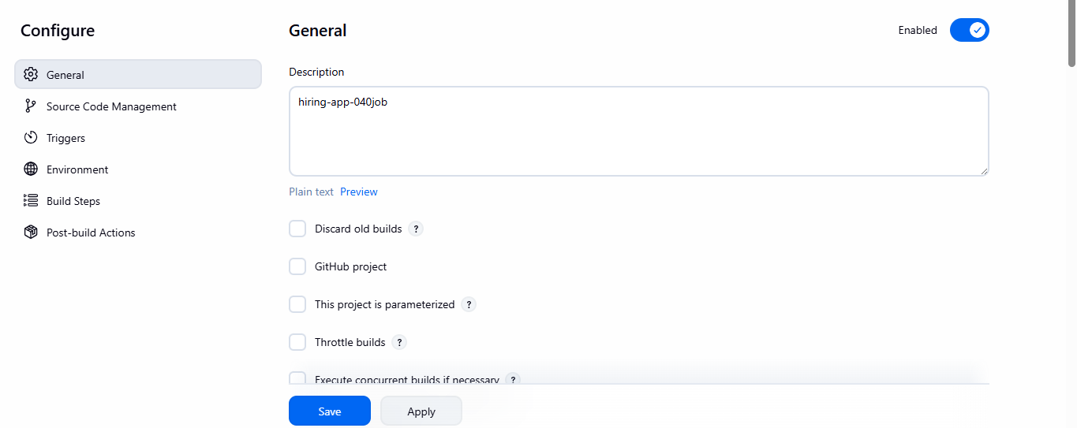
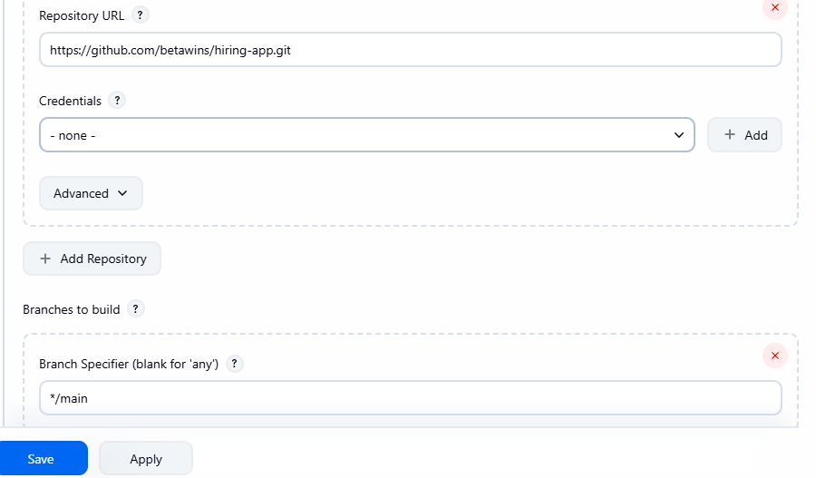
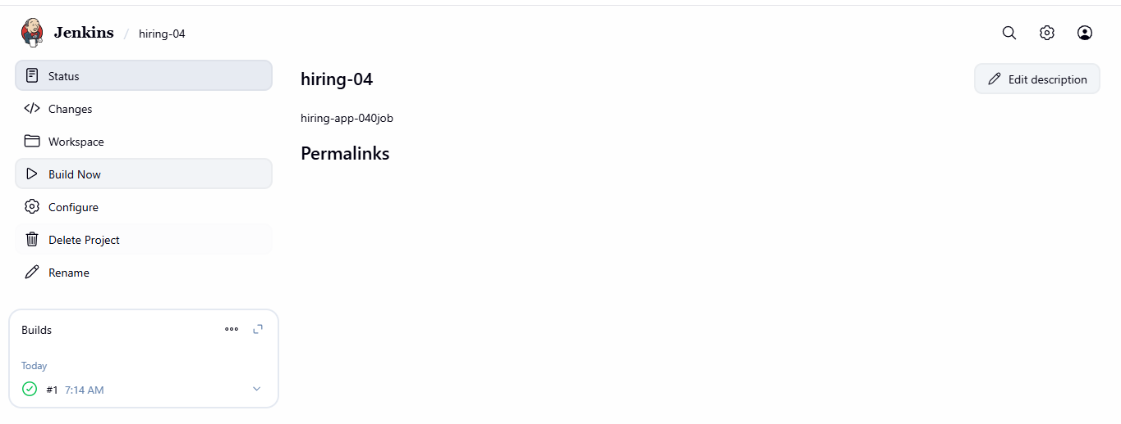
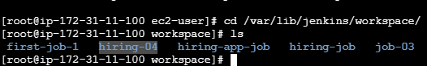
here you can see the github- Repository clone successfully.
SonarQube Integration:
🧩 PART 1: Create SonarQube EC2 Instance

1️⃣ Launch EC2
- AMI: Amazon Linux 2
- Instance type: t3.medium (minimum 4 GB RAM ❗)
- Storage: 20 GB
- Auto-assign Public IP: Enabled

2️⃣ Security Group (VERY IMPORTANT)
Add inbound rules:
Port | Purpose
22 | SSH
9000 | SonarQube UI

🧩 PART 2: Install Docker on SonarQube Instance
SSH into instance:
ssh -i key.pem ec2-user@<PUBLIC_IP>
Install Docker:
sudo yum update -y
sudo yum install docker -y
sudo systemctl start docker
sudo systemctl enable docker
Add user to Docker group:
sudo usermod -aG docker ec2-user
newgrp docker
Verify:
docker --version

🧩 PART 3: Run SonarQube Using Docker (BEST METHOD)

1️⃣ Create data directory
sudo mkdir -p /opt/sonarqube
sudo chown -R 999:999 /opt/sonarqube

2️⃣ Start SonarQube container
docker run -d \
--name sonarqube \
-p 9000:9000 \
-v /opt/sonarqube:/opt/sonarqube/data \
--restart=unless-stopped \
sonarqube:lts

3️⃣ Watch logs (wait 2–3 minutes)
docker logs -f sonarqube
Wait until you see:
SonarQube is up

🧩 PART 4: Access SonarQube UI
Open browser:
http://<SONAR_PUBLIC_IP>:9000

Default login:
Username: admin
Password: admin
👉 It will ask you to change password (do it).

🧩 PART 5: Create SonarQube Project
- Click Create Project
- Choose Manual
- Project key:
- my-app
- Project name:
- My Application
- Click Set Up

🧩 PART 6: Generate SonarQube Token (IMPORTANT)
- When prompted, select Generate a token
- Token name:
- jenkins-token
- Click Generate
- COPY THE TOKEN ⚠️
(You cannot see it again)
Example:
sqp_9a8bc123xxxxxx

🧩 PART 7: Add SonarQube Token in Jenkins
Go to Jenkins UI:

1️⃣ Manage Credentials
Manage Jenkins → Credentials → Global → Add Credentials

2️⃣ Add credential
- Kind: Secret Text
- Secret: <PASTE_SONAR_TOKEN>
- ID: sonar-token
- Description: SonarQube Token
Save ✔

🧩 PART 8: Configure SonarQube in Jenkins (GLOBAL)

1️⃣ Install Required Plugin
Manage Jenkins → Plugins → Available
Install:
- SonarQube Scanner
Restart Jenkins if asked.

2️⃣ Configure SonarQube Server
Manage Jenkins → Configure System
Scroll to SonarQube servers:
- Name:
- sonarqube-server
- Server URL:
- http://<SONAR_PUBLIC_IP>:9000
- Server authentication token:
- sonar-token
Save ✔

🧩 PART 9: Configure Sonar Scanner Tool
Manage Jenkins → Global Tool Configuration
Under SonarQube Scanner:
- Name:
- sonar-scanner
- Install automatically ✔
Save ✔

🧩 PART 10: Verify Connection from Jenkins

Test in Jenkins job or pipeline

Declarative pipeline example:
withSonarQubeEnv('sonarqube-server') {
sh '''
mvn sonar:sonar \
-Dsonar.projectKey=my-app \
-Dsonar.projectName="My Application"
'''
}

🧩 PART 11: Verify in SonarQube Dashboard
- Go back to SonarQube UI
- Open My Application
- You should see:
  - Bugs
  - Vulnerabilities
  - Code Smells
  - Coverage
✅ This confirms Jenkins ↔ SonarQube integration works.
Steps to done for Sonarqube integration:
stages:
first need to click on job clcik on configure jobScroll down till Environment.
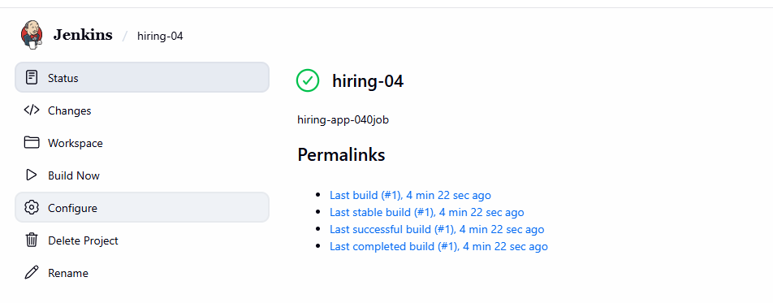
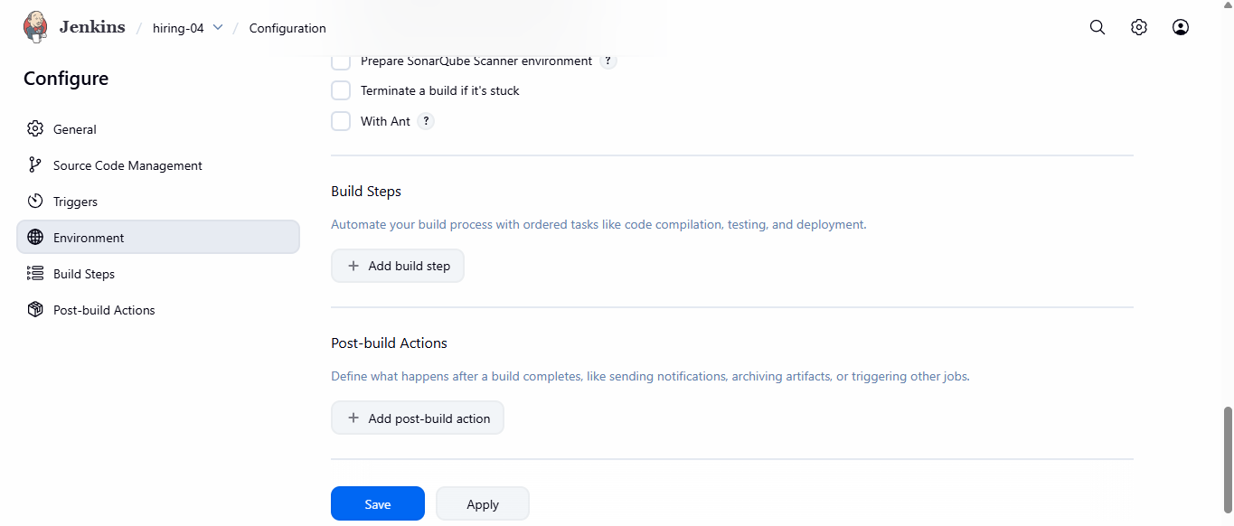
Step2: click on add build stepthen add your analysis properties.
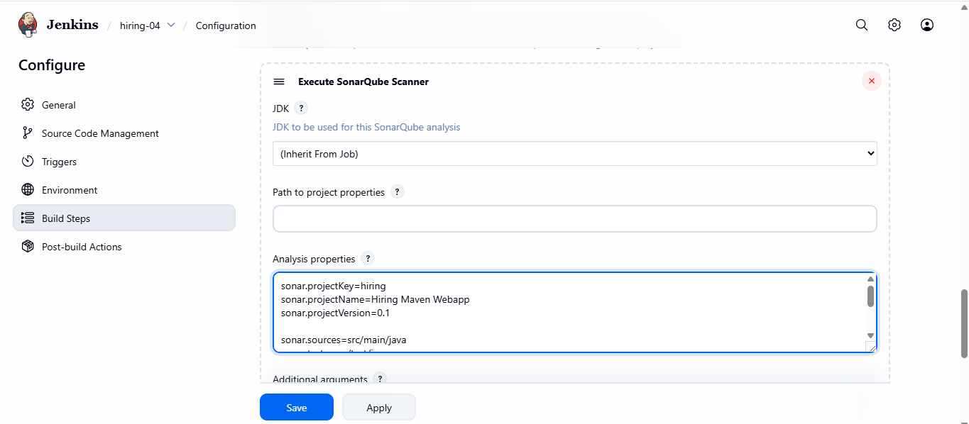
add these lines in analysis properties.
{ sonar.projectKey=Test
sonar.sources=.}
then click on build now to job.
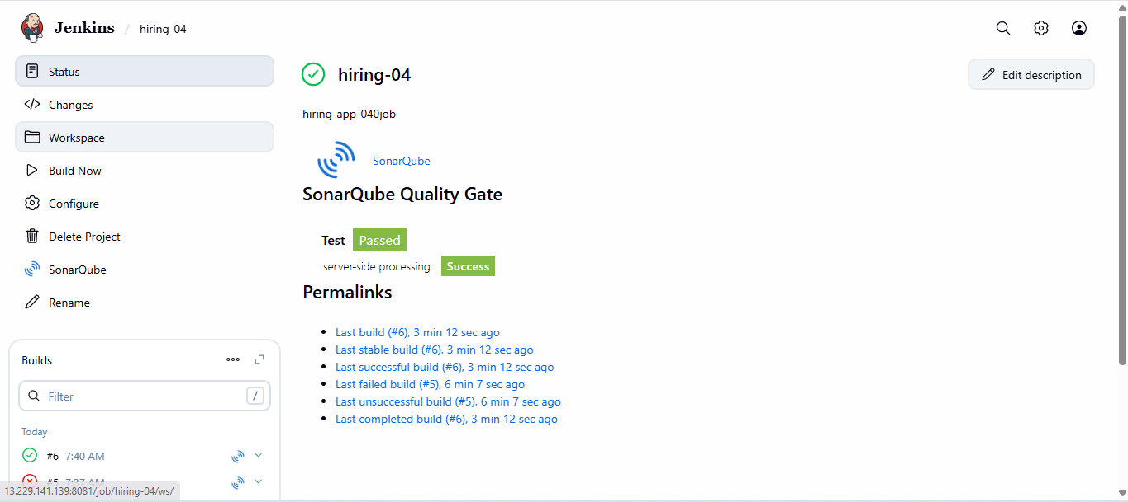
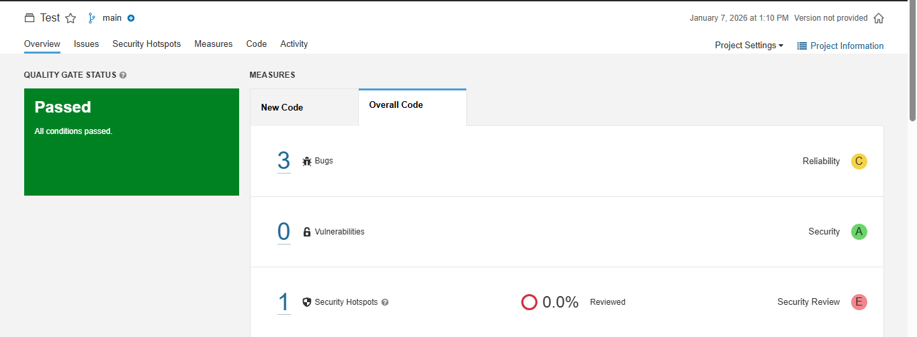
now you can see the result of job.
Maven Compilation:
Prerequisites for Maven
we can use the Jenkins server but it is good if we create new instance.
created new instance.
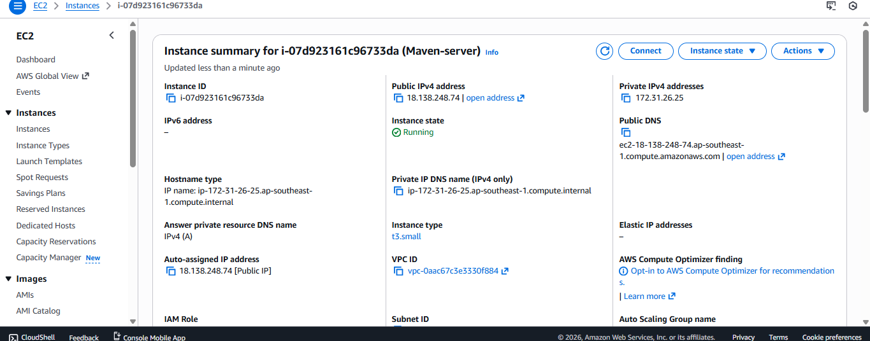
then need to go to browser and search maven download
copy link address of binary tar file.
wget <URL>
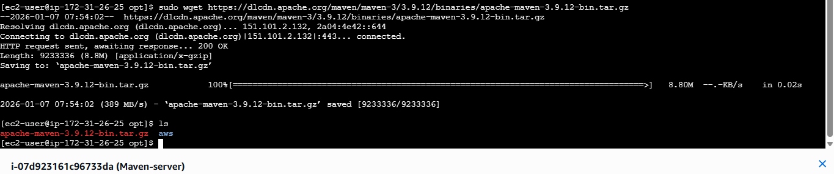
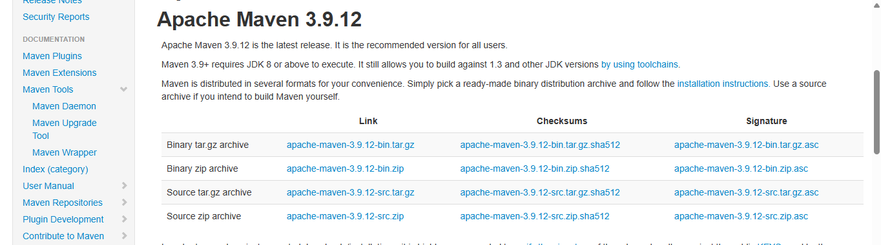
then need to set the location of maven in <.bash_profile> file in this file set
[# .bash_profile

# Get the aliases and functions
if [ -f ~/.bashrc ]; then
. ~/.bashrc
fi

# User specific environment and startup programs
MVN_HOME=/opt/maven/bin
PATH=$PATH:$HOME/bin:$MVN_HOME
export PATH]
then run this command >source ~/.bash_profile.
run mvn –version
then copy the location of mvn startup file and then paste in Jenkins. 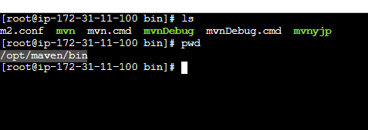
open jenkins GUI manage jenkinsTools scroll down till maven.
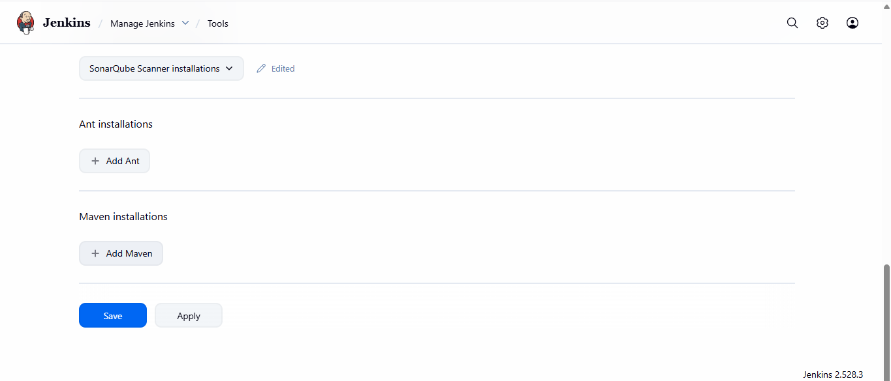
click on add maven add name [MVN_HOME]add hoem location[/opt/maven]save
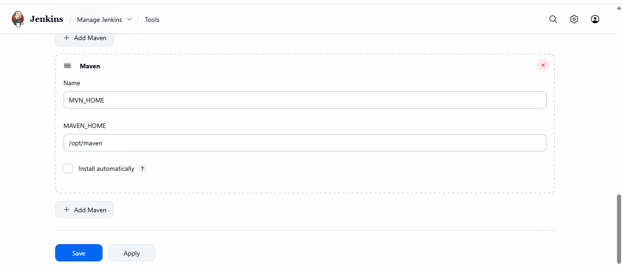
then go to jenkin job configurescroll down till build step select invoke top level maven.
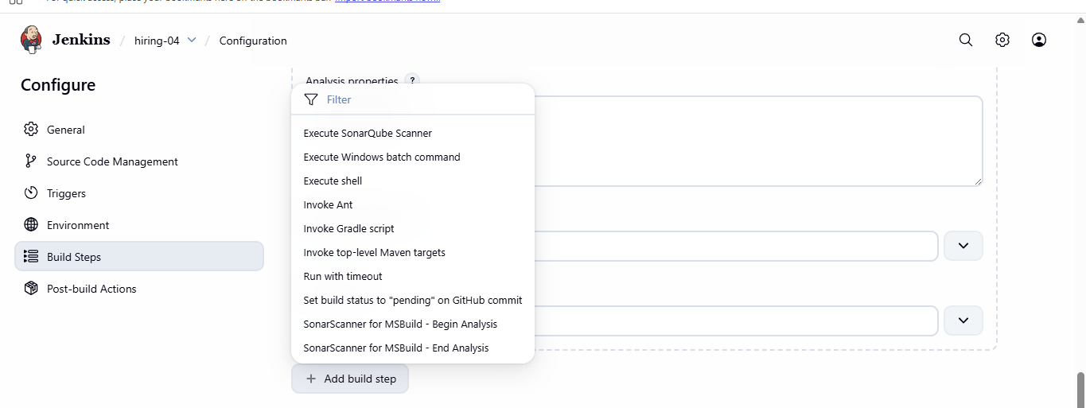
select MVN_HOMEadd the command [clean install]Save.
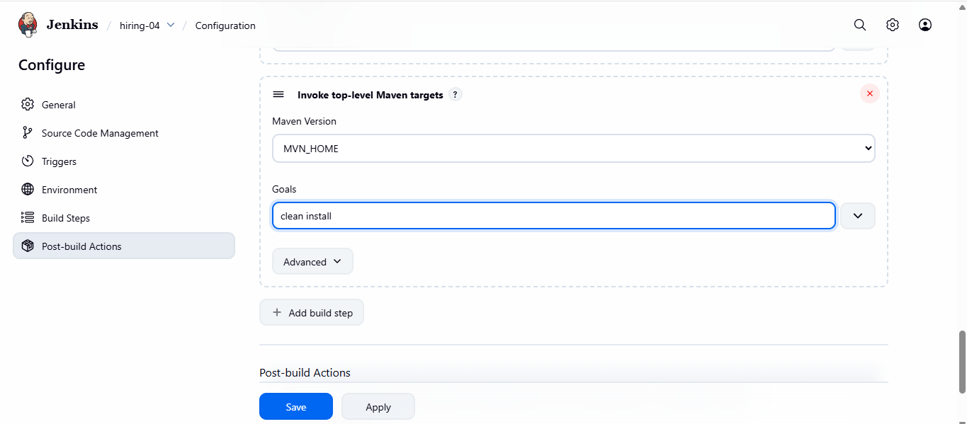
After saving the job configuratiuonclick on buil now the job will create a package in your job dir.
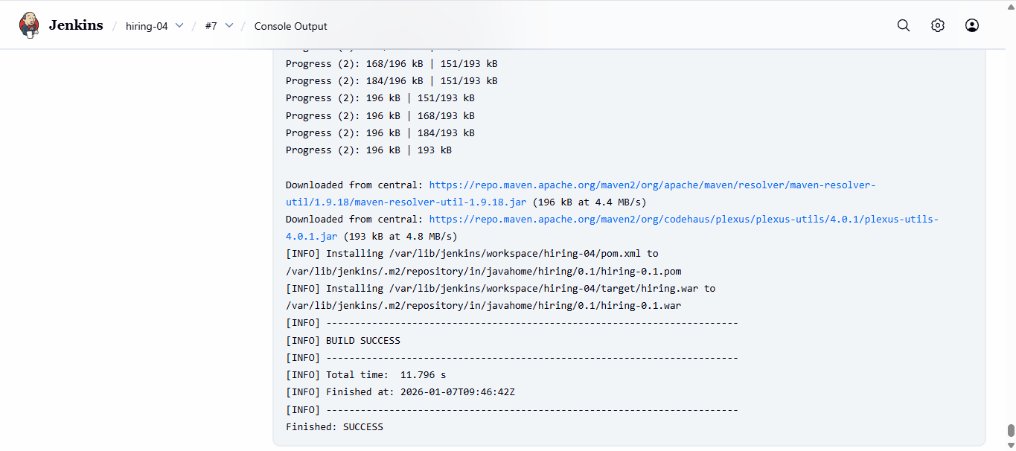
here you can see the *Target dir package has been created.
To store the packages in nexus need to create new instance and store the artifactory in nexus.
Nexus Artifactory:
prerequisites for nexus:
launxh a new server:
Steps: Connect to the nexus server and check the java --version
Now install java > yum install java-1.8* -y
then download nexus in /opt/ directory.
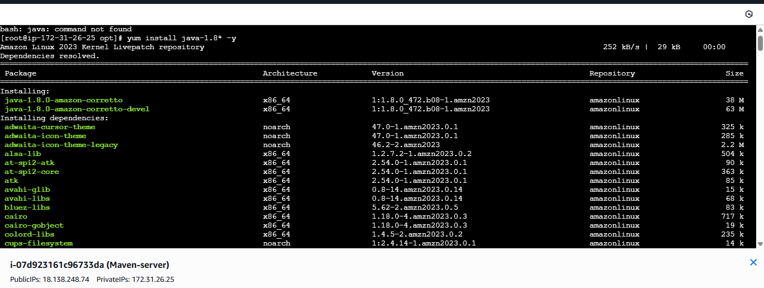
then download nexus in nexus server after java setup
wget wget https://download.sonatype.com/nexus/3/nexus-3.0.2-02-unix.tar.gz
then untar the nexus dir <tar xvf nexus3.0.2.02> <mv nexus 3.0.2.02 nexus> change name.
changing the user name by edit this filevi /opt/nexus/bin/nexus.rc
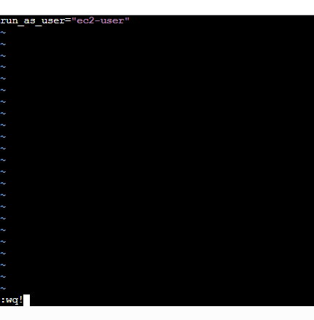
changing the ownership of nexus directorycd /opt
chown –R ec2-user:ec2-user nexus.
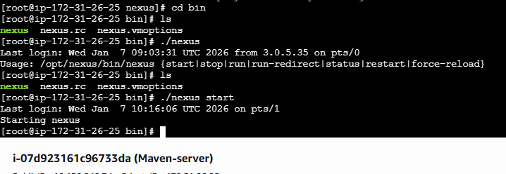
once the nexus shows starting it will take 5 min to load
go to security group in instance security edit inboundallow 8081.
then go copy public ip:8081
sign in by default <username:admin> <passwd:admin123>
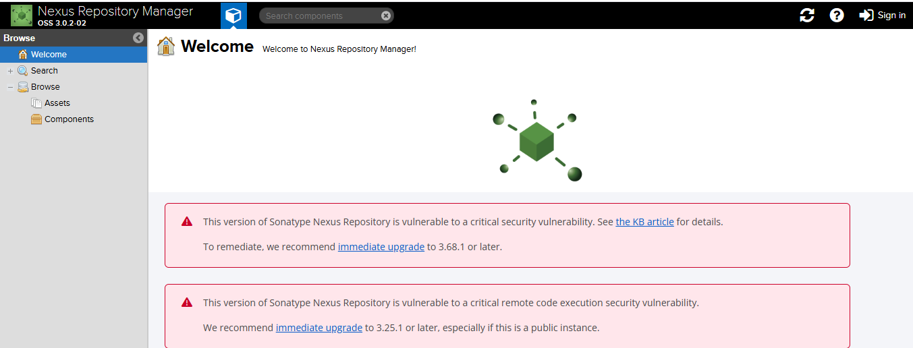
Once the nexus show go to Jenkinsplugginle plugins.
NEXUS ARTIFACTORY UPLOAD.
INSTALL WITHOUT RESTART.
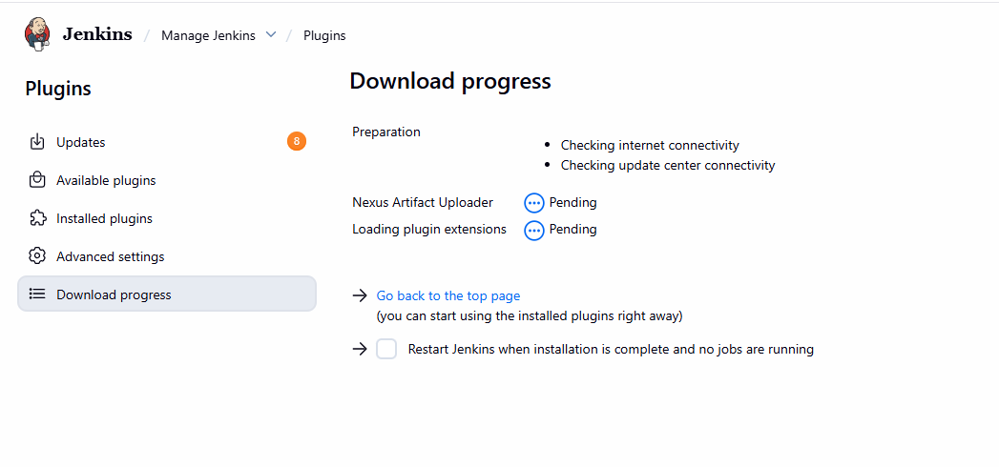
Then go to your job configurationscroll down till post build action.
Select nexus artifactory uploader.
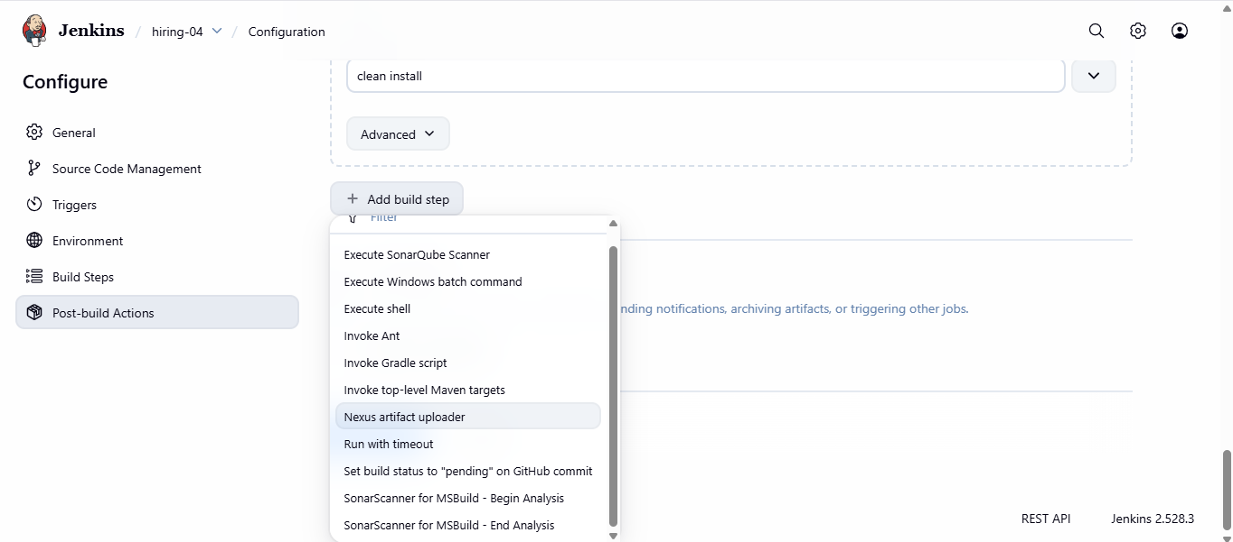
select NEXUS# version protocol httpURL<ip:8081>
credentialadd credentialsclick on Jenkins.
then after adding the nexus credentialopen pom.xml file from github repository.
select the group id versionthen for repository go to nexus website.
click on repositoryclick on create repositoryselect maven2hosted
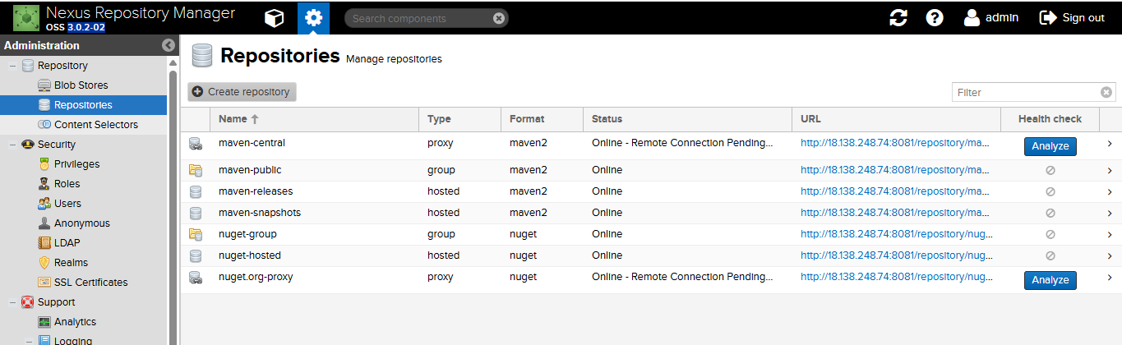
assign nameversion policy[release]I chose release because 0.1 version don’t support snapshot.
layout policy[permissive]deployment policy[allow redeploy]
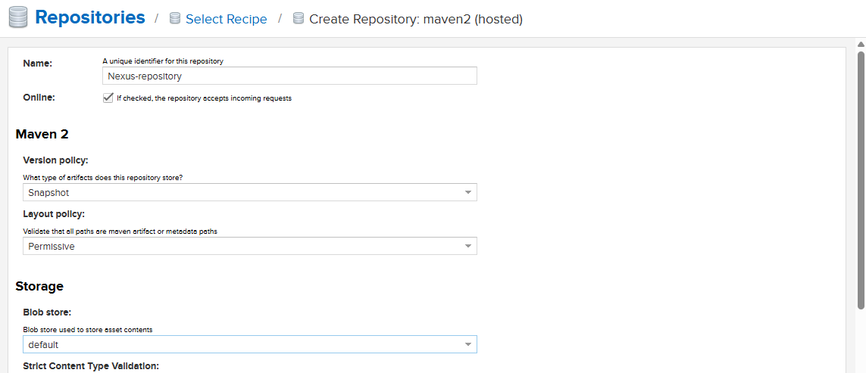
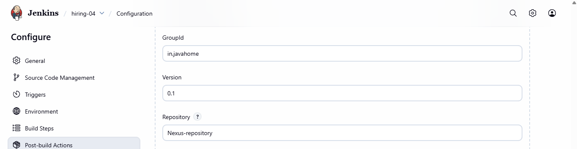
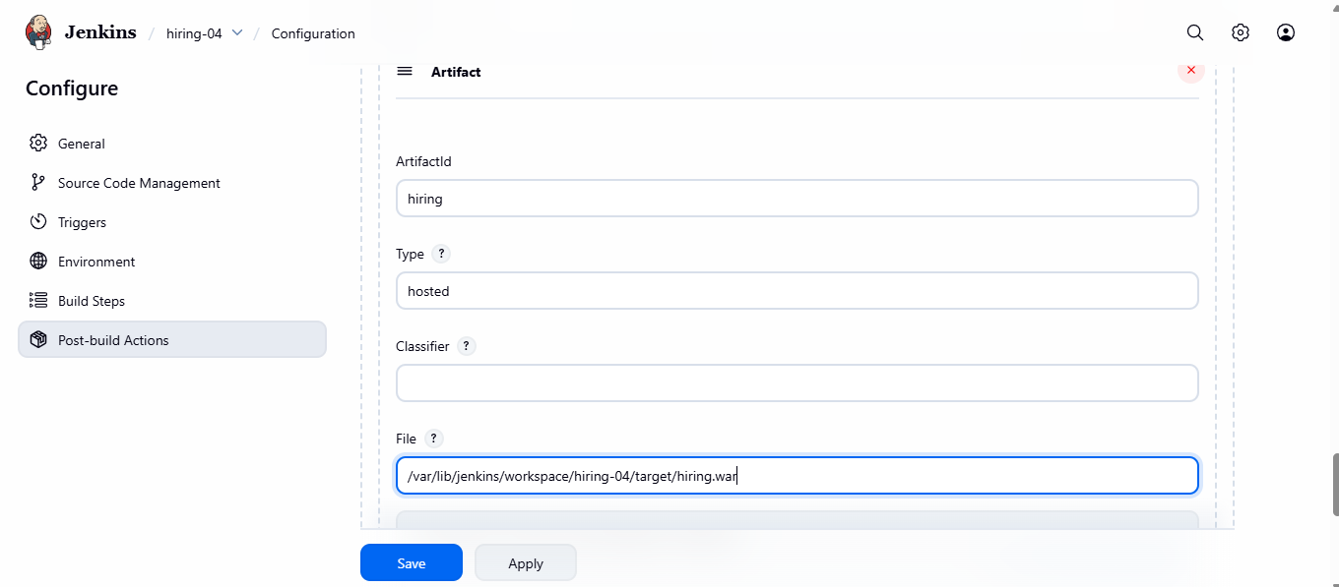
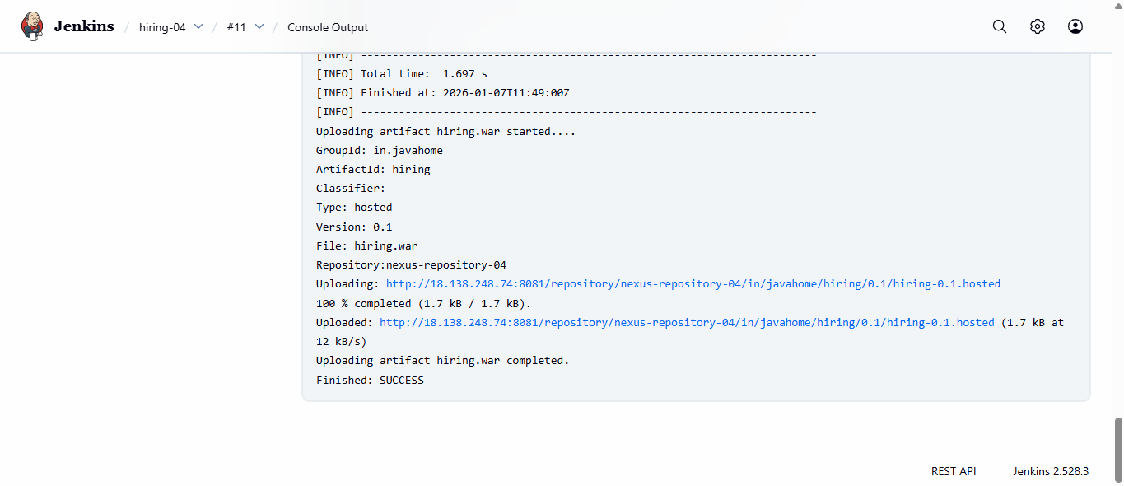
after the build is successfully triggerthen your can see the files in nexus repositories.
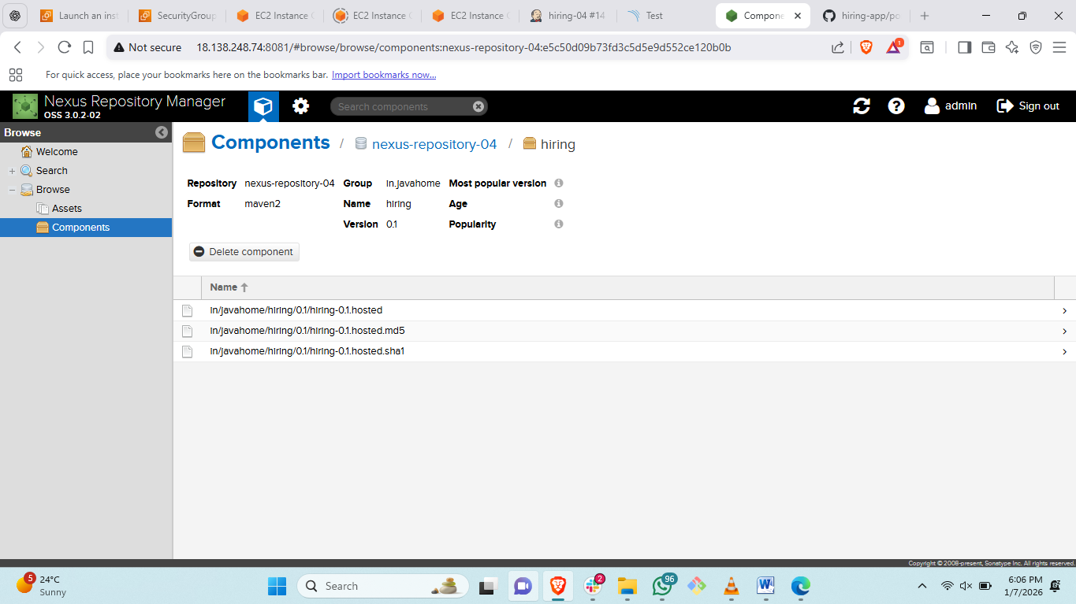
Slack Notification:
steps: to add slack notification.
go to job configurationscroll down till post job build.
add slack notification in post job build.
select <notigy if job success>and <notify if job fails>
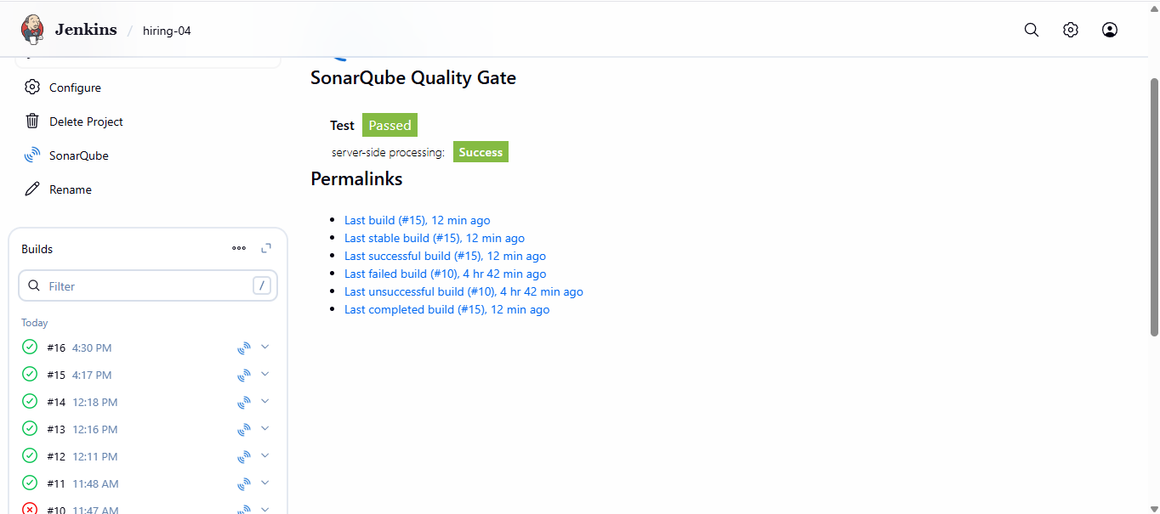
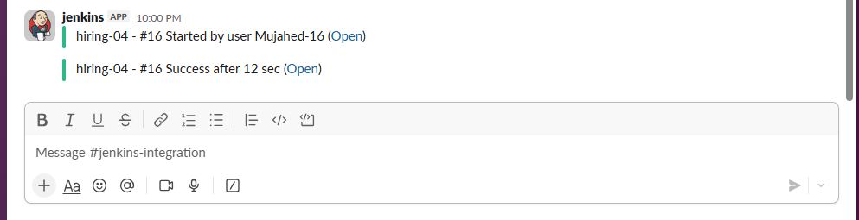
Deploy On tomcat:
first need to launch a instance for tomcatthen install java 17 version
wget tomcat 9.0 versionstart tomcat check the status of tomcat.
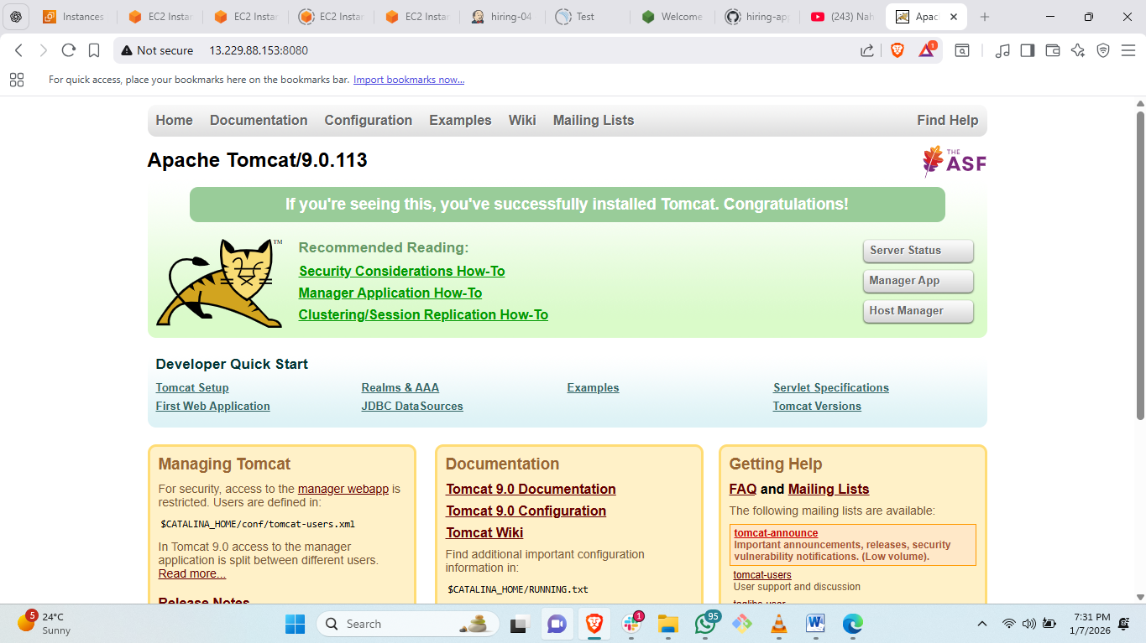
then need to edit four files of tomcat.
find / -name context.xml
four file from down we need to edit> in edit we need to uncomment.
first file edited.
2nd file edited.
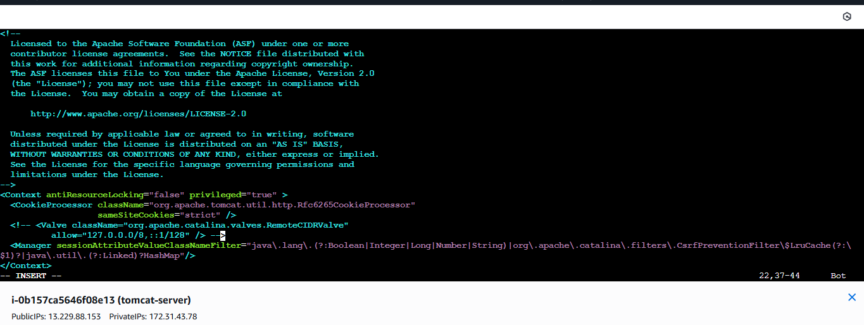
3rd file is edited
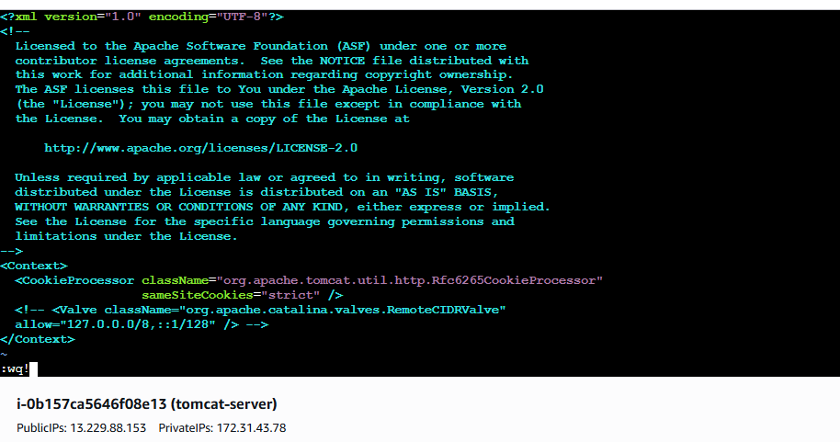
4th file edited
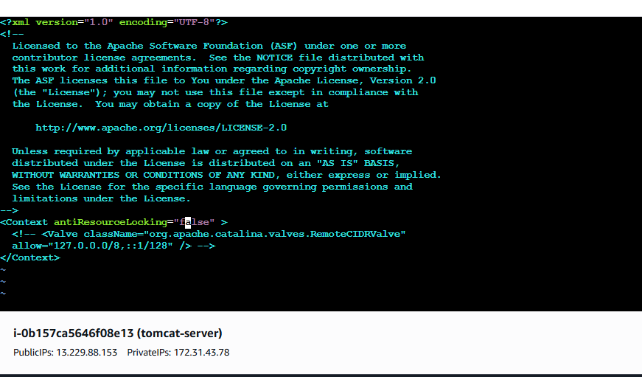
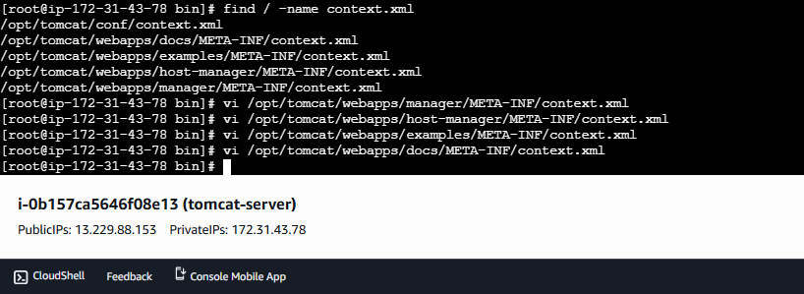
now go to /opt/tomcat/conf edit this file <tomcat-user.xml>
add this details in this file for user and password.
<role rolename="manager-gui"/>
<role rolename="manager-script"/>
<role rolename="manager-jmx"/>
<role rolename="manager-status"/>
<user username="admin" password="admin" roles="manager-gui,manager-script,managerjmx,manager-status"/>
<user username="deployer" password="deployer" roles="manager-script"/>
<user username="tomcat" password="s3cret" roles="manager-gui"/>
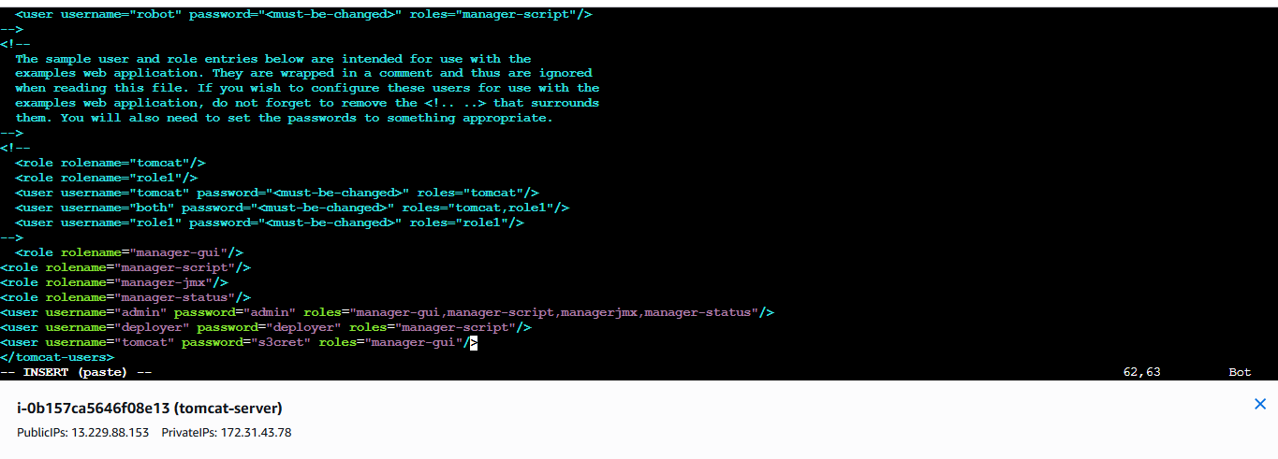
then go to browser search <tomcat public ip:8080>
click on server status and login with <username: admin>
passwd :admin
then go to Jenkins click on manage Jenkinsplugginsinstall pluggin
install Deploy to container> pluggin install
then go to job credentials scroll down till add post buildselect <deploy to container.
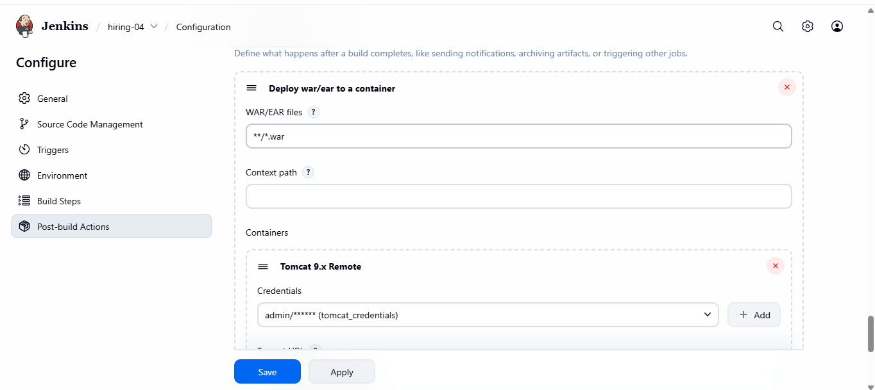
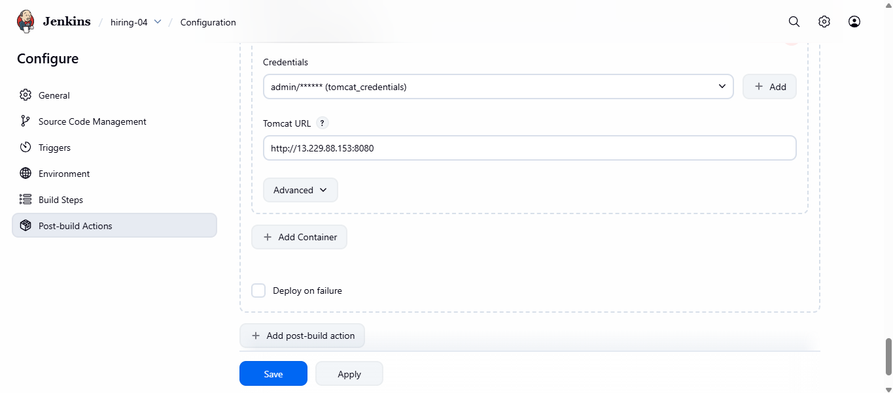
addcredential username: admin passwd :adminid: tomcat_credentialsdescription:same.
select tomcat credential add tomcat URLsave.
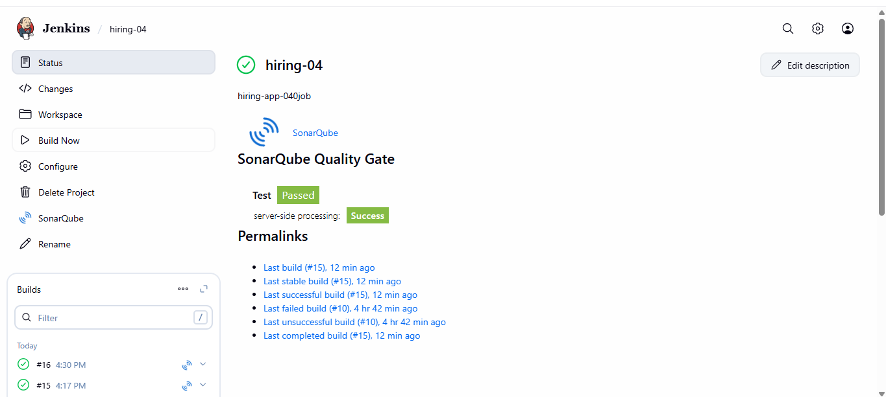
#finally the job 1 is success.
2. Setup a Jenkins CICD pipeline using Declarative pipeline using feature-1.1 branch. https://github.com/betawins/sabear_simplecutomerapp/tree/feature-1.1
stages:
Git Clone:
steps1: first login to Jenkins GUI and click on new item.
then assign a name to your project and
select pipeline
first need to make a declarative pipeline
create a declarative pipeline
syntax for cloning the Repository.
pipeline {
agent any

stages {
stage('Git Clone') {
steps {
git branch: 'feature-1.1',
url: 'https://github.com/betawins/sabear_simplecutomerapp.git'
}
}
}
}
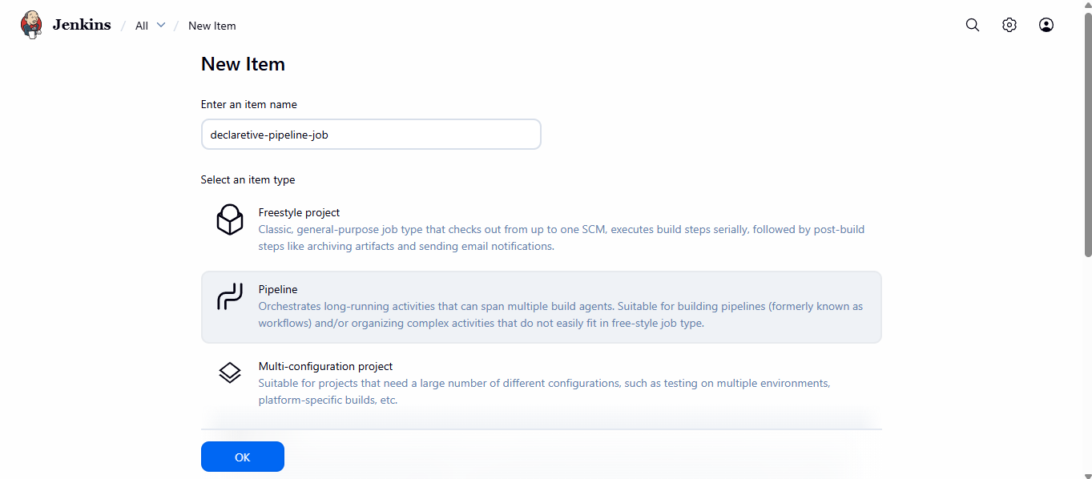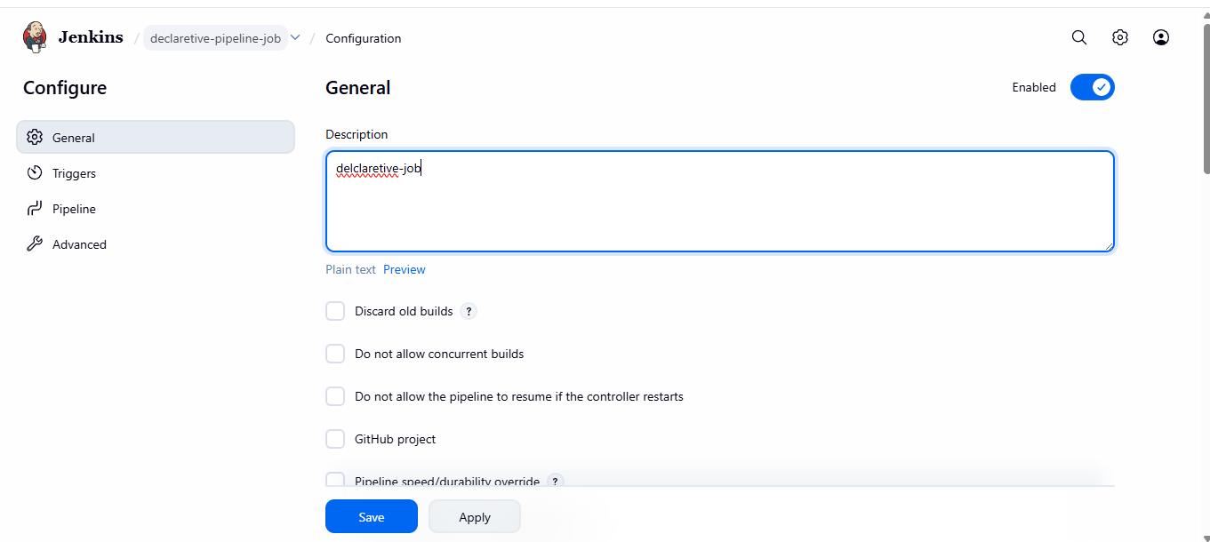
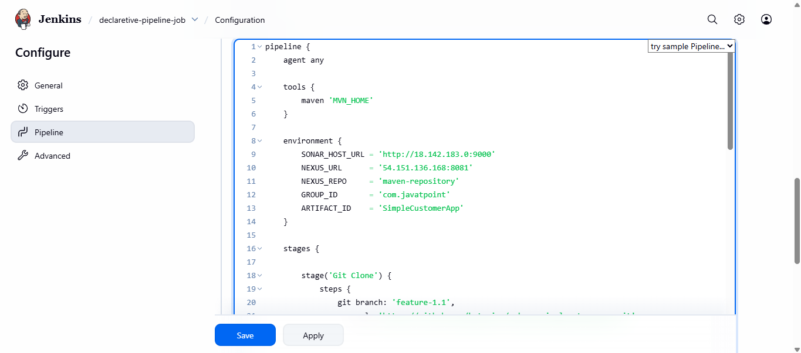
syntax for cloning the Repository.
pipeline {
agent any

stages {
stage('Git Clone') {
steps {
git branch: 'feature-1.1',
url: 'https://github.com/betawins/sabear_simplecutomerapp.git'
}
}
}
}
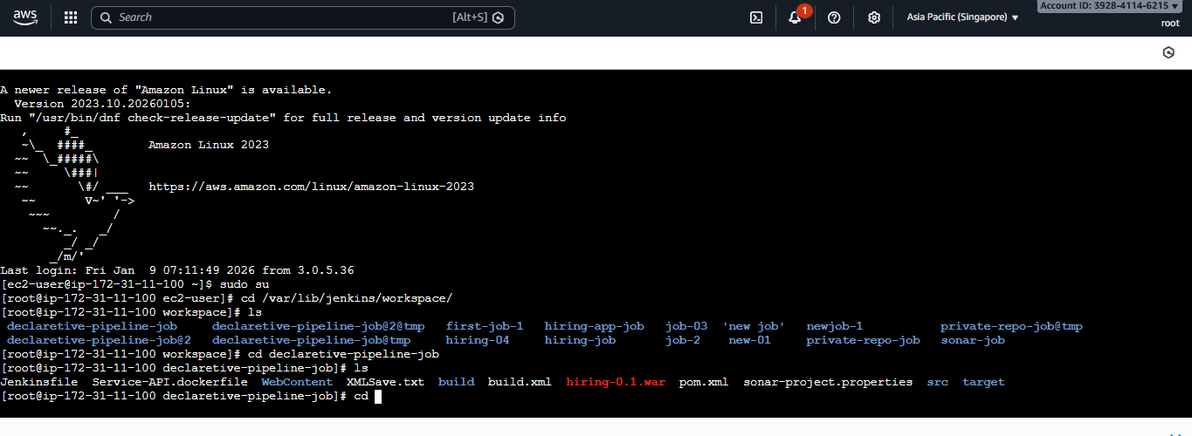
last step: go to Jenkins server cd /var/lib/Jenkins/workspace/
there yo can see the job clone to the Jenkins.
SonarQube Integration:
first need to make sure you have sonarqube server and login to sonar qube server with <ip:9000>this sonarqube run on port number 9000.
then create token and add in jenkinmanage Jenkins
configurationadd the token in system.
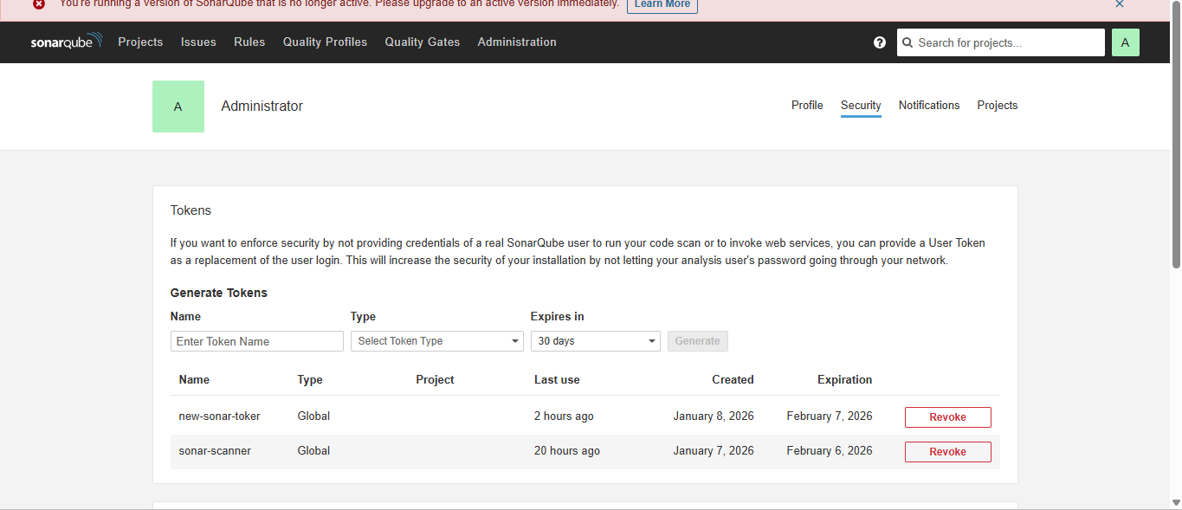
check the jenkinmanage jenkiinssystem 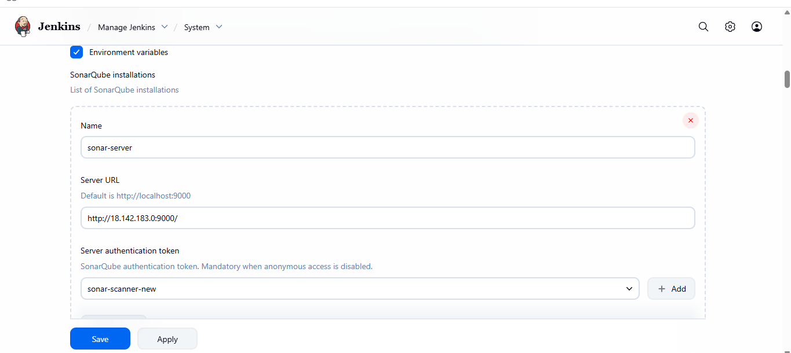
then add this detail in Jenkins job declarative pipe line.
stage('SonarQube Analysis') {
steps {
withSonarQubeEnv('sonar-server') {
sh '''
/opt/sonar-scanner/bin/sonar-scanner \
-Dsonar.projectKey=SimpleCustomerApp \
-Dsonar.projectName=SimpleCustomerApp \
-Dsonar.sources=src \
-Dsonar.exclusions=**/*.java
'''
}
}
}
this is the syntax of decarative pipeline.
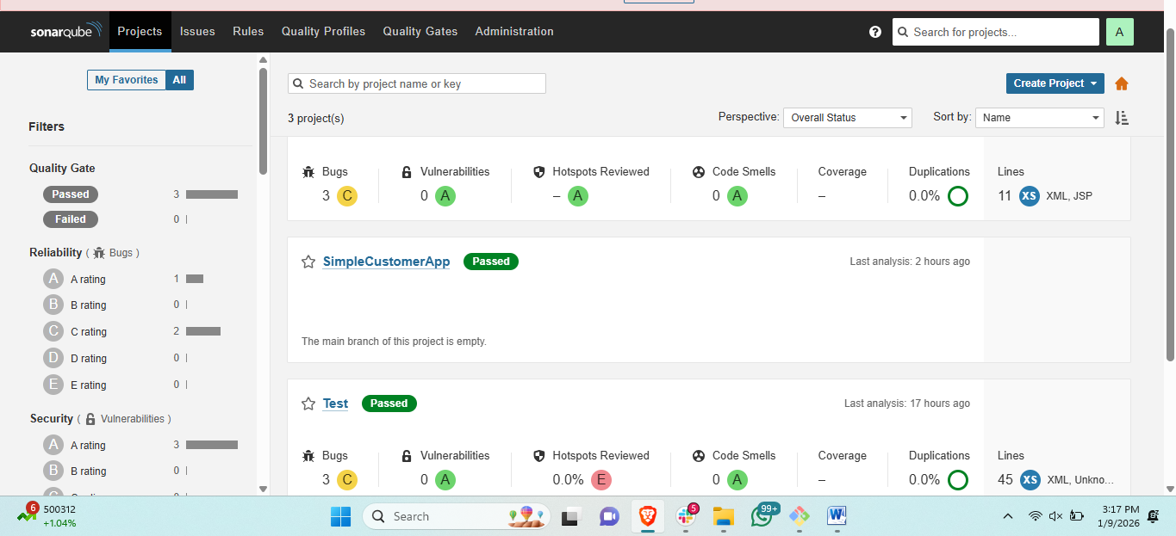
Maven Compilation
first need to make sure you have setup the maven is Jenkins
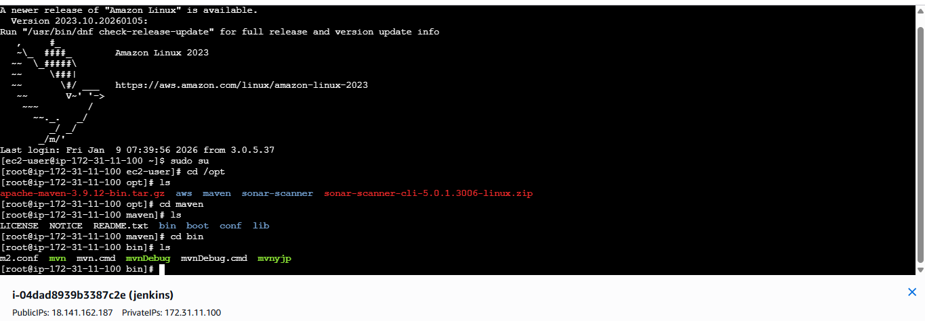
and make sure the .bash_profile file is edit
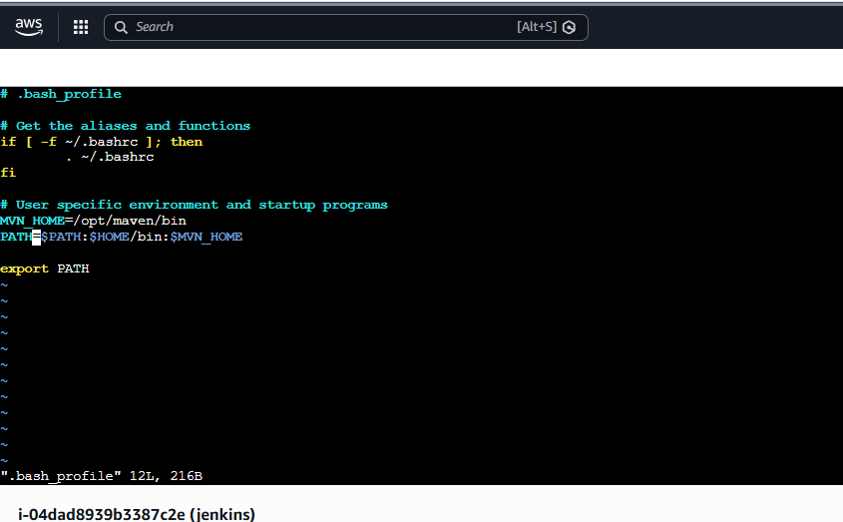
then create a declarative pipeline in Jenkins.
syntax for maven.
stage('Maven Build') {
steps {
sh 'mvn clean package -DskipTests'
}
}
Nexus Artifactory:
first need to make sure you have nexus server and setup nexus
create repository for storing the artifactory.
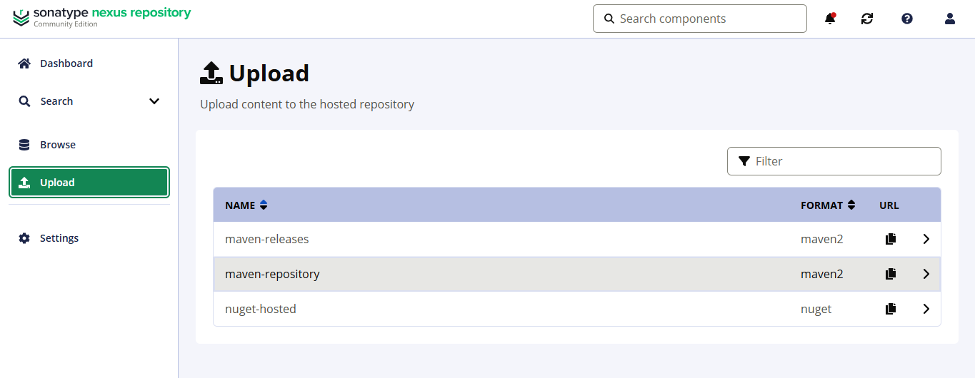
then need to add the details of created maven repository.
need to create a declarative pipeline in Jenkins job
stage('Copy WAR from .m2') {
steps {
sh '''
cp /var/lib/jenkins/.m2/repository/in/javahome/hiring/0.1/hiring-0.1.war .
ls -l hiring-0.1.war
'''
}
}
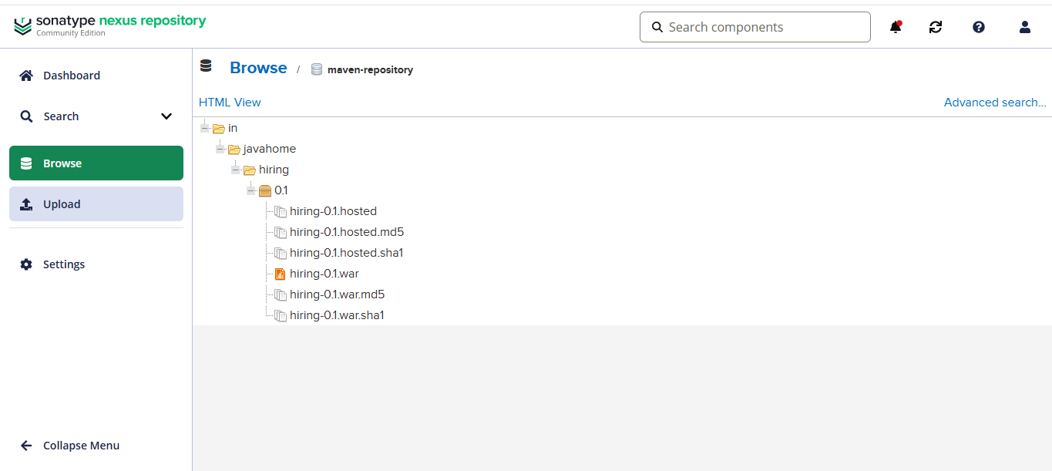
Slack Notification
first we need to configure slack notification in Jenkins.
steps to configure:
step1: install pulggin injenkinssearch slack notification in Jenkins pluggin.
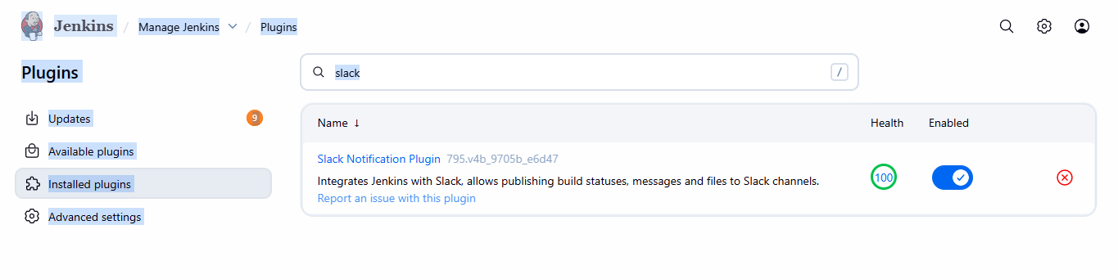
step2:go to slack application search for app in slackjenkins cl.
download and configure it will provide the slack name and secret key of slack.
then go to Jenkins GUI andmanage Jenkinssystemscroll down to post build stepadd slack channel and credential and channel name.
Deploy On tomcat:
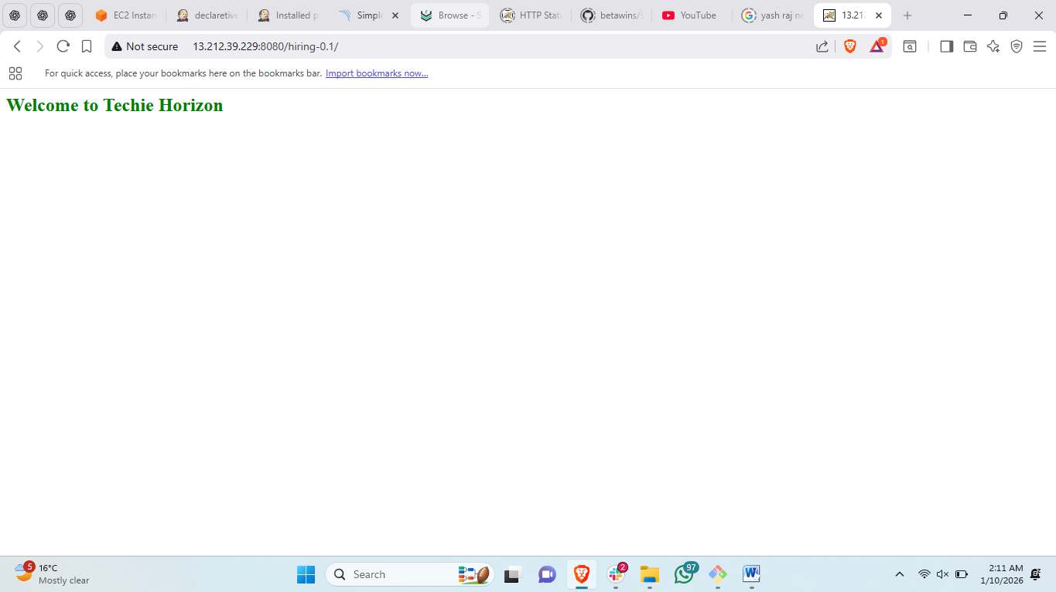
Declarative pipeline I have used.
pipeline {
agent any

tools {
maven 'MVN_HOME'
}

environment {
SONAR_SCANNER = '/opt/sonar-scanner/bin/sonar-scanner'
NEXUS_URL = '54.151.136.168:8081'
NEXUS_REPO = 'maven-repository'
}

stages {

stage('Git Clone') {
steps {
git branch: 'feature-1.1',
url: 'https://github.com/betawins/sabear_simplecutomerapp.git'
}
}

stage('Maven Build') {
steps {
sh 'mvn clean package -DskipTests'
}
}

stage('SonarQube Analysis') {
steps {
withSonarQubeEnv('sonar-server') {
sh """
${SONAR_SCANNER} \
-Dsonar.projectKey=SimpleCustomerApp \
-Dsonar.projectName=SimpleCustomerApp \
-Dsonar.sources=src \
-Dsonar.exclusions=**/*.java
"""
}
}
}

stage('Copy WAR from .m2') {
steps {
sh '''
cp /var/lib/jenkins/.m2/repository/in/javahome/hiring/0.1/hiring-0.1.war .
ls -l hiring-0.1.war
'''
}
}

stage('Upload to Nexus') {
steps {
nexusArtifactUploader(
nexusVersion: 'nexus3',
protocol: 'http',
nexusUrl: "${NEXUS_URL}",
repository: "${NEXUS_REPO}",
credentialsId: 'nexus_repo',
groupId: 'in.javahome',
version: '0.1',
artifacts: [[
artifactId: 'hiring',
type: 'war',
file: 'hiring-0.1.war'
]]
)
}
}

stage('Deploy to Tomcat') {
steps {
deploy adapters: [tomcat9(
credentialsId: 'tomcat_credentials',
url: 'http://13.212.39.229:8080'
)],
contextPath: '',
war: 'hiring-0.1.war'
}
}
}

post {
success {
slackSend(
channel: '#jenkins-integration',
color: 'good',
message: """✅ *PIPELINE SUCCESS*
Job: ${env.JOB_NAME}
Build: #${env.BUILD_NUMBER}
URL: ${env.BUILD_URL}
"""
)
}

failure {
slackSend(
channel: '#jenkins-integration',
color: 'danger',
message: """❌ *PIPELINE FAILED*
Job: ${env.JOB_NAME}
Build: #${env.BUILD_NUMBER}
URL: ${env.BUILD_URL}
"""
)
}
}
}
3. Setup a Jenkins CICD pipeline using Scripted pipeline using feature-1.1 branch. https://github.com/betawins/sabear_simplecutomerapp/tree/feature-1.1
stages: 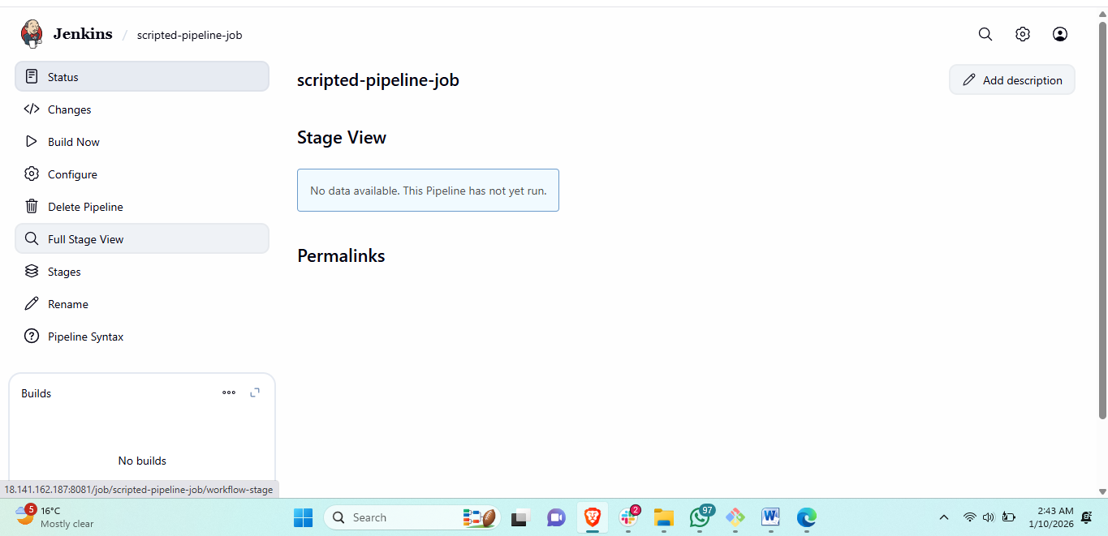
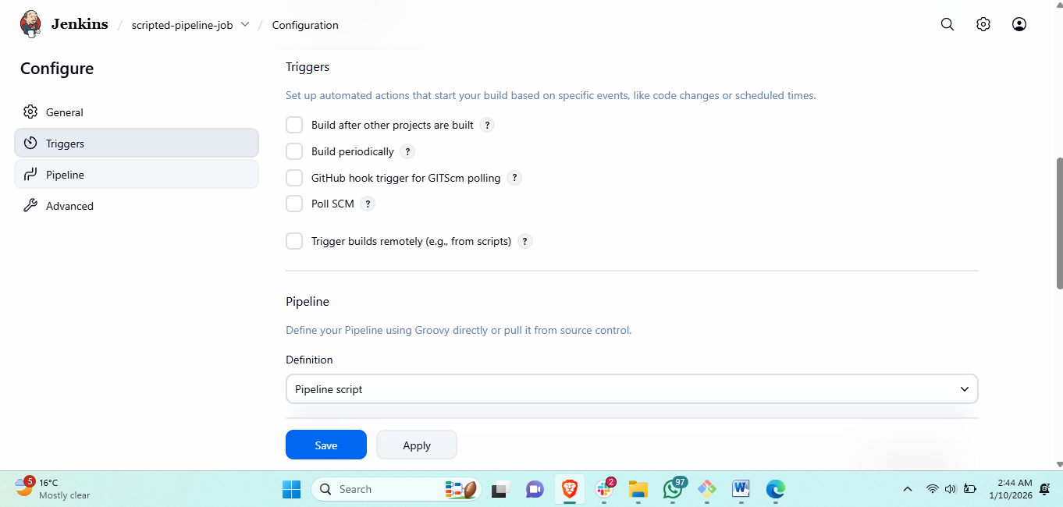
used script for job:
node {

def SONAR_SCANNER = '/opt/sonar-scanner/bin/sonar-scanner'
def NEXUS_URL = '54.151.136.168:8081'
def NEXUS_REPO = 'maven-repository'

try {

/* ===== Tool setup ===== */
def mvnHome = tool name: 'MVN_HOME', type: 'maven'

/* ===== Git Clone ===== */
stage('Git Clone') {
git branch: 'feature-1.1',
url: 'https://github.com/betawins/sabear_simplecutomerapp.git'
}

/* ===== Maven Build ===== */
stage('Maven Build') {
withEnv(["PATH+MAVEN=${mvnHome}/bin"]) {
sh 'mvn clean package -DskipTests'
}
}

/* ===== SonarQube Analysis ===== */
stage('SonarQube Analysis') {
withSonarQubeEnv('sonar-server') {
sh """
${SONAR_SCANNER} \
-Dsonar.projectKey=SimpleCustomerApp \
-Dsonar.projectName=SimpleCustomerApp \
-Dsonar.sources=src \
-Dsonar.exclusions=**/*.java
"""
}
}

/* ===== Copy WAR ===== */
stage('Copy WAR from .m2') {
sh '''
cp /var/lib/jenkins/.m2/repository/in/javahome/hiring/0.1/hiring-0.1.war .
ls -l hiring-0.1.war
'''
}

/* ===== Upload to Nexus ===== */
stage('Upload to Nexus') {
nexusArtifactUploader(
nexusVersion: 'nexus3',
protocol: 'http',
nexusUrl: NEXUS_URL,
repository: NEXUS_REPO,
credentialsId: 'nexus_repo',
groupId: 'in.javahome',
version: '0.1',
artifacts: [[
artifactId: 'hiring',
type: 'war',
file: 'hiring-0.1.war'
]]
)
}

/* ===== Deploy to Tomcat ===== */
stage('Deploy to Tomcat') {
deploy adapters: [tomcat9(
credentialsId: 'tomcat_credentials',
url: 'http://13.212.39.229:8080'
)],
contextPath: '',
war: 'hiring-0.1.war'
}

/* ===== Slack SUCCESS ===== */
slackSend(
channel: '#jenkins-integration',
color: 'good',
message: """✅ *PIPELINE SUCCESS*
Job: ${env.JOB_NAME}
Build: #${env.BUILD_NUMBER}
URL: ${env.BUILD_URL}
"""
)

} catch (err) {

/* ===== Slack FAILURE ===== */
slackSend(
channel: '#jenkins-integration',
color: 'danger',
message: """❌ *PIPELINE FAILED*
Job: ${env.JOB_NAME}
Build: #${env.BUILD_NUMBER}
URL: ${env.BUILD_URL}
"""
)

throw err
Git Clone:
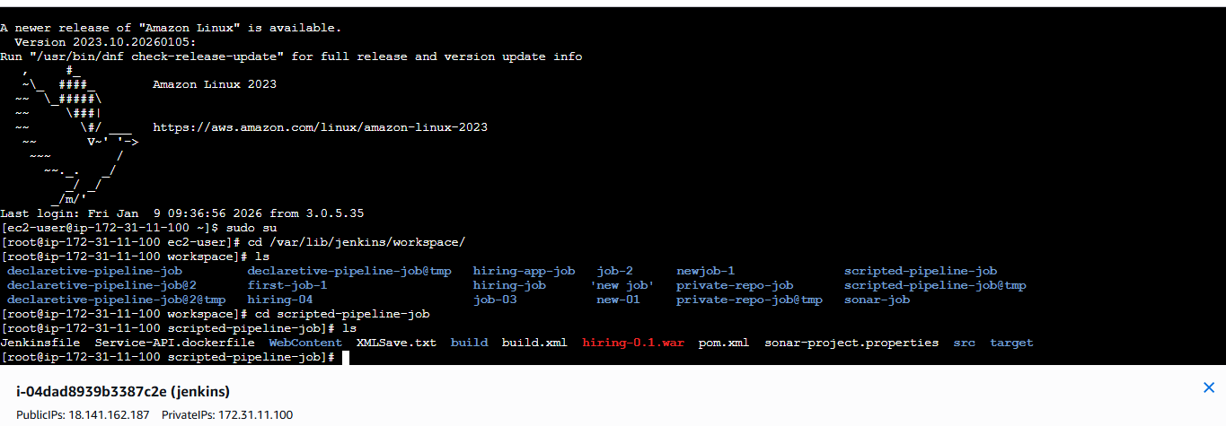
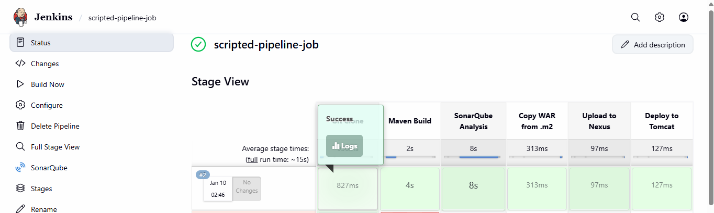
SonarQube Integration:
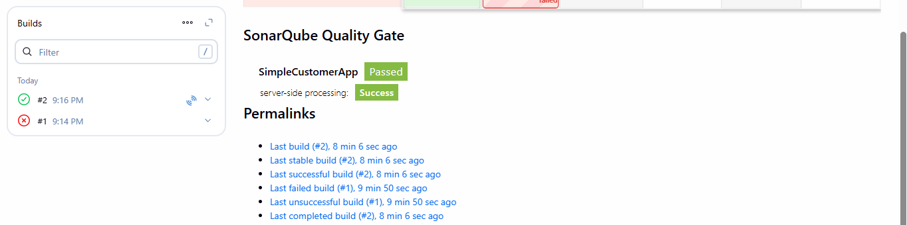
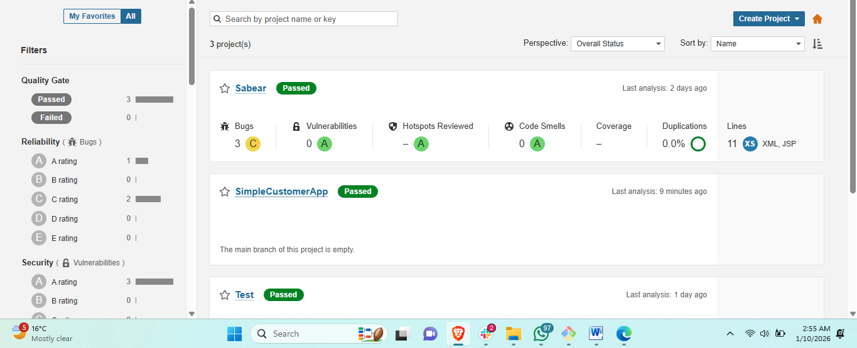
Maven Compilation
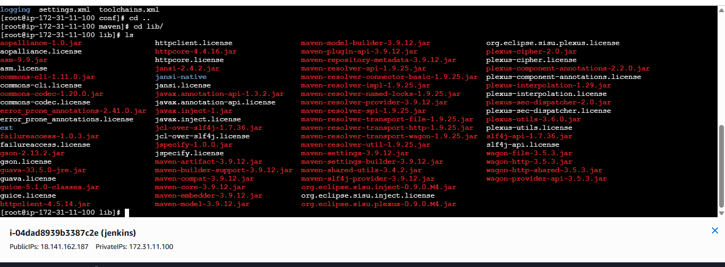
Nexus Artifactory:
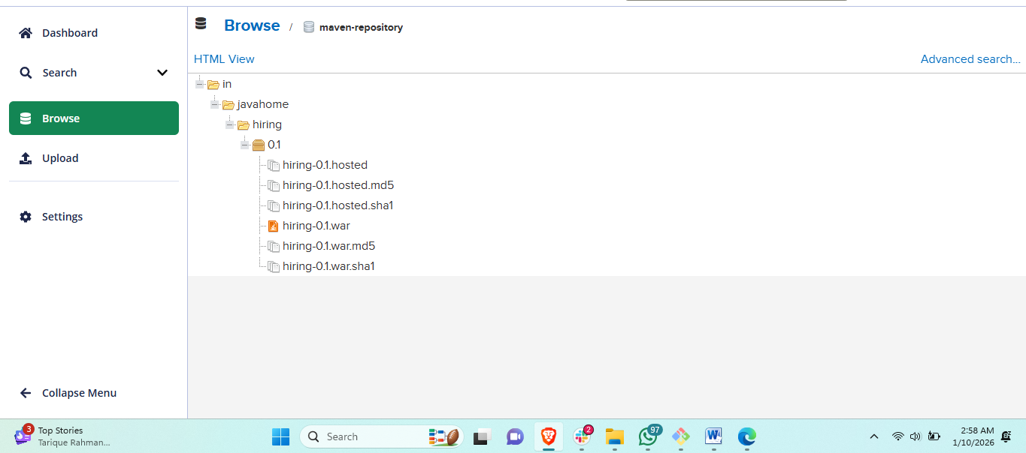
Slack Notification
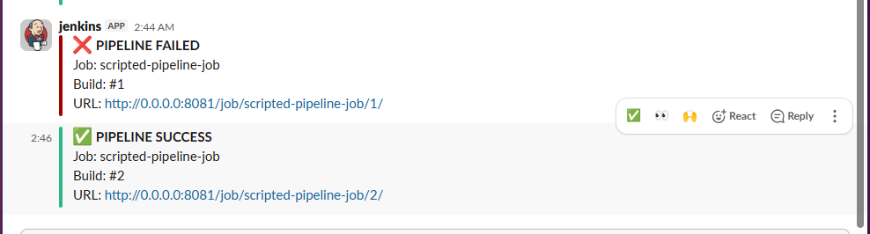
Deploy On tomcat
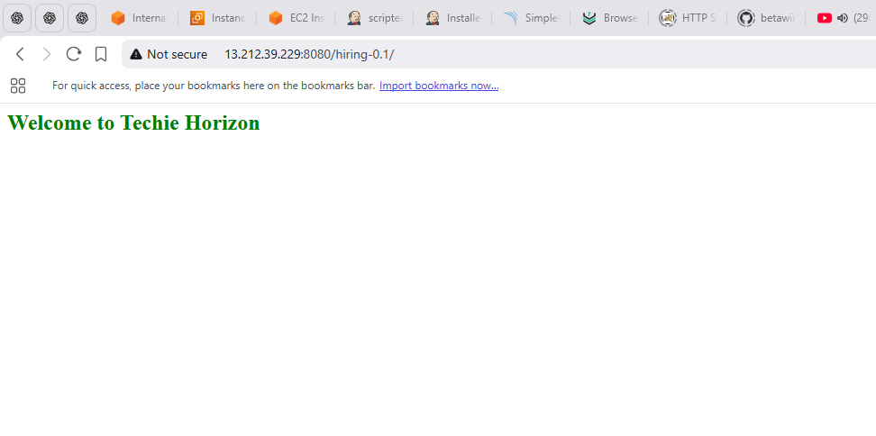
4. Write sample skeleton of pipelines.
Jenkins Pipelines – Declarative vs Scripted

1) Declarative Pipeline – Skeleton

Declarative Pipeline Example
pipeline {
agent any

stages {

stage('Git Clone') {
steps {
git 'https://github.com/your-repo/sample-app.git'
}
}

stage('Build') {
steps {
sh 'mvn clean install'
}
}

stage('SonarQube Analysis') {
steps {
withSonarQubeEnv('sonarqube-server') {
sh 'sonar-scanner'
}
}
}

stage('Deploy') {
steps {
sh 'cp target/*.war /opt/tomcat/webapps/'
}
}
}

post {
success {
echo 'Build Successful'
}
failure {
echo 'Build Failed'
}
}
}

Conclusion – Declarative Pipeline
Declarative pipeline uses a structured and predefined syntax, which makes it:
- Easier to read
- Easier to maintain
- Less error-prone
It is ideal for standard CI/CD pipelines and team environments.

2) Scripted Pipeline – Skeleton

Scripted Pipeline Example
node {

stage('Git Clone') {
git 'https://github.com/your-repo/sample-app.git'
}

stage('Build') {
sh 'mvn clean install'
}

stage('SonarQube Analysis') {
withSonarQubeEnv('sonarqube-server') {
sh 'sonar-scanner'
}
}

stage('Deploy') {
sh 'cp target/*.war /opt/tomcat/webapps/'
}
}

Conclusion – Scripted Pipeline
Scripted pipeline uses Groovy scripting and provides:
- More flexibility
- More control
- Advanced conditional logic
It is best suited for complex workflows and dynamic pipeline behavior.
5. Create a parameterized job in Jenkins. https://github.com/betawins/spring3-mvc-maven-xml-hello-world-1.git
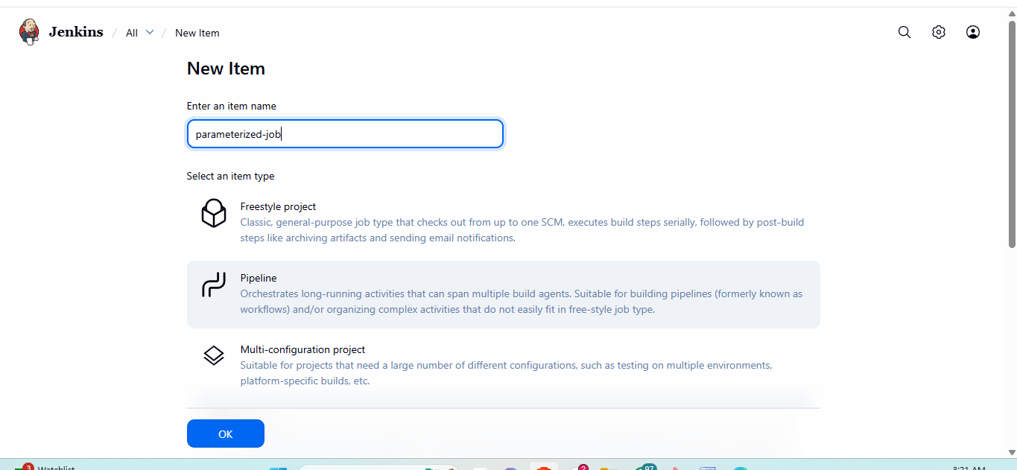
Creating a Parameterized Jenkins Pipeline Step 1
. Start a New Pipeline Job
1. In Jenkins, click New Item.
2. Name your job and select Pipeline, then click OK
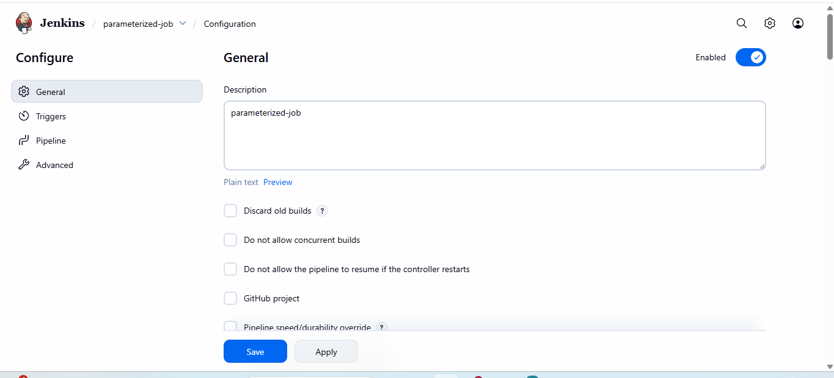
Step 2: Add Parameters in Jenkins
1. Go to Jenkins Dashboard → Your Job → Configure.
2. Check This project is parameterized.
3. Add the following parameters:
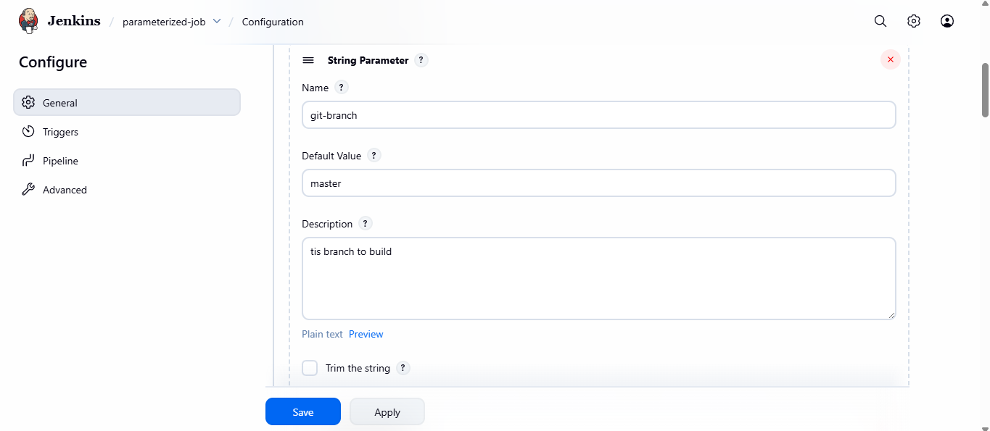
1. String Parameter
o Name: GIT_BRANCH
o Default Value: master
o Descrip on: Git branch to build from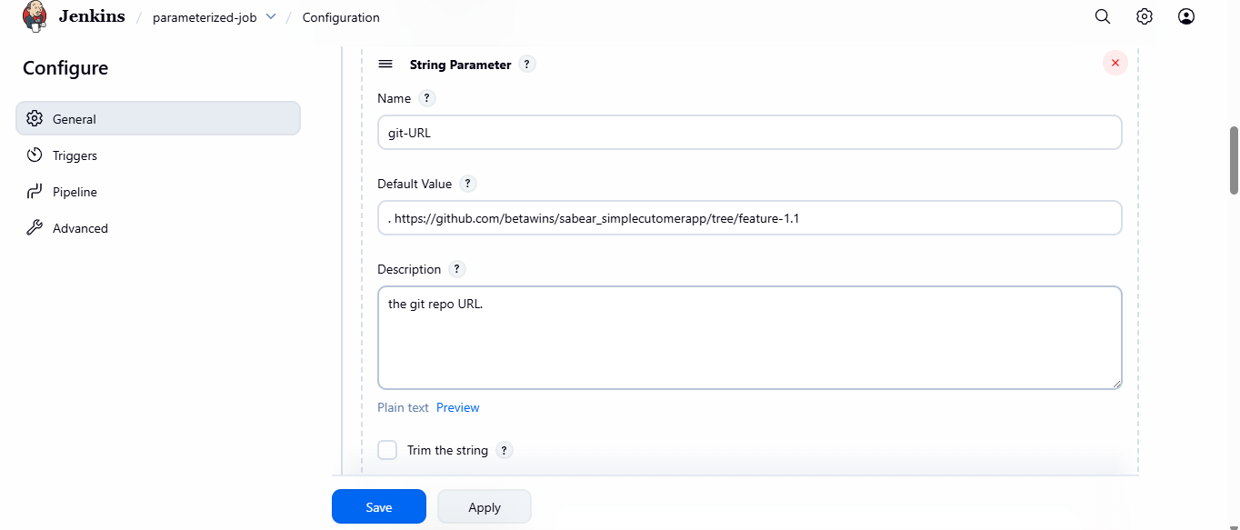
2. String Parameter
o Name: GIT_URL
o Default Value: . https://github.com/betawins/sabear_simplecutomerapp/tree/feature-1.1
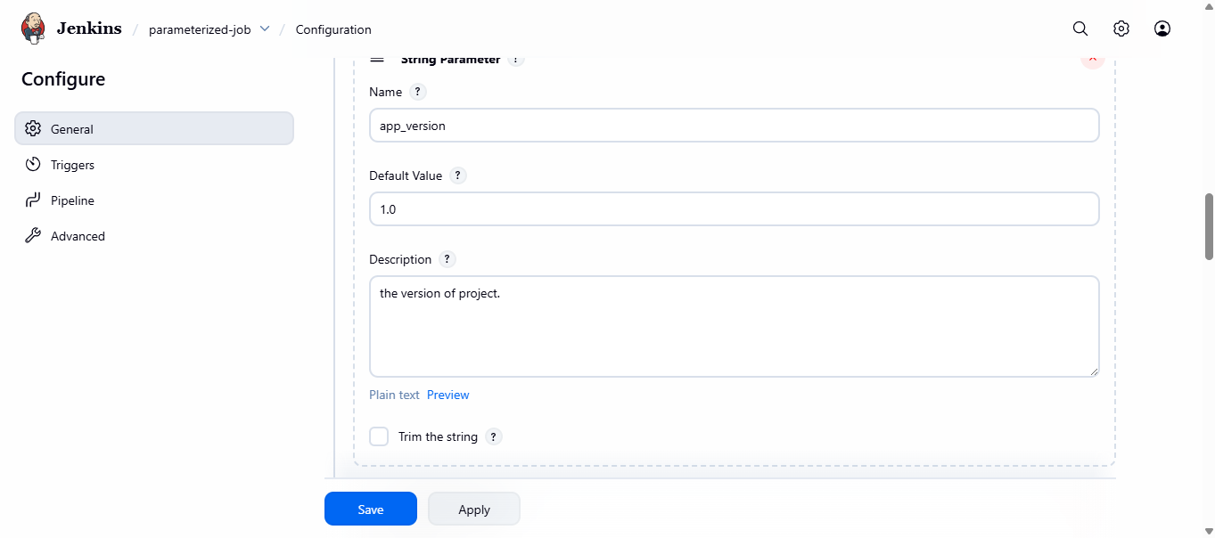
3. String Parameter
o Name: APP_VERSION
o Default Value: 1.0
o Descrip on: Applica on version to deploy
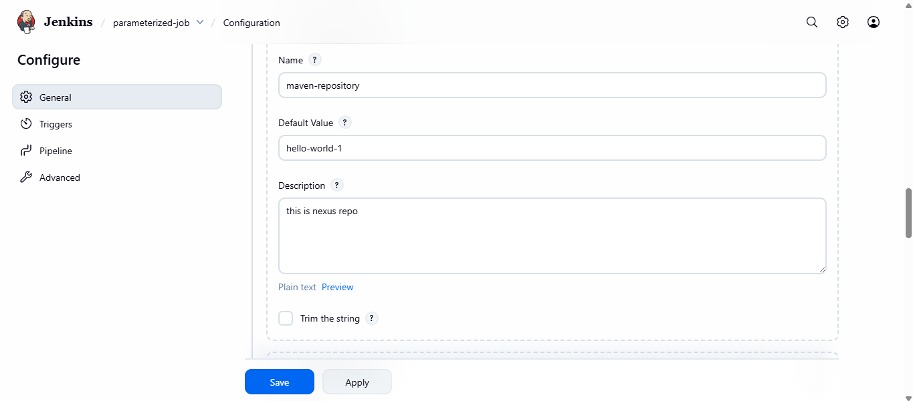
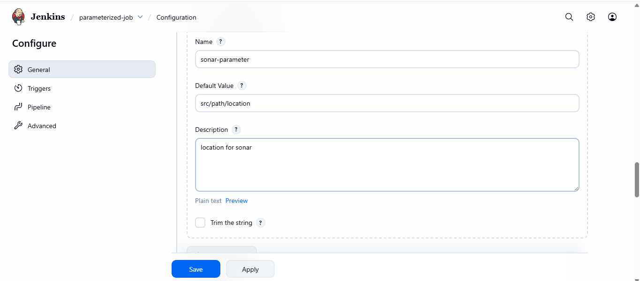
4. String Parameter
o Name: NEXUS_REPO
o Default Value: hiring-app

o Descrip on: Nexus repository name
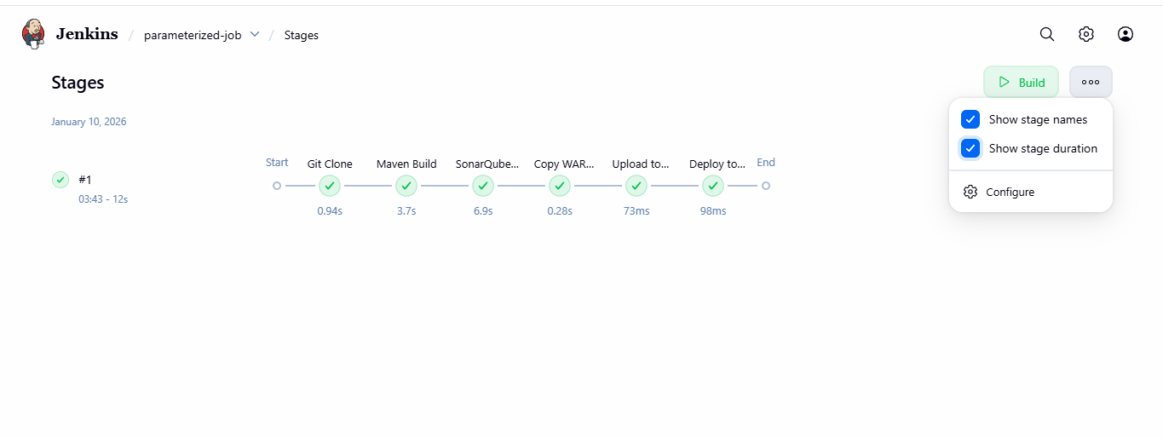
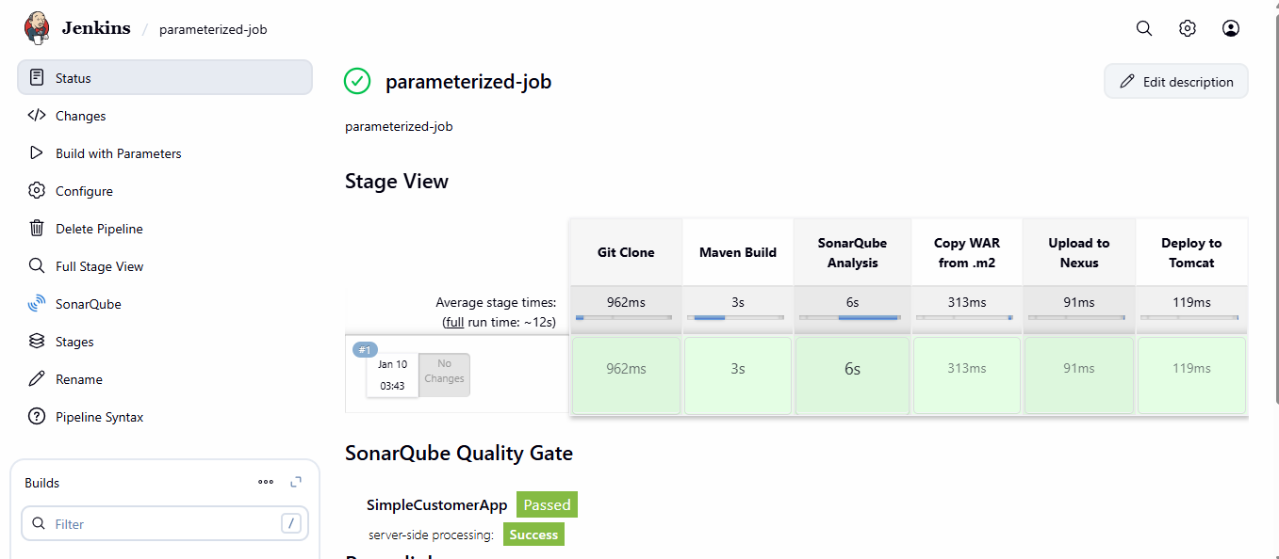
6. Setup one slave machine for Jenkins.
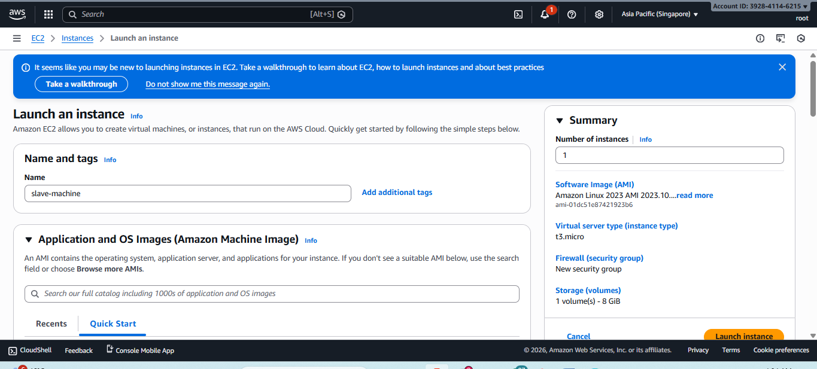
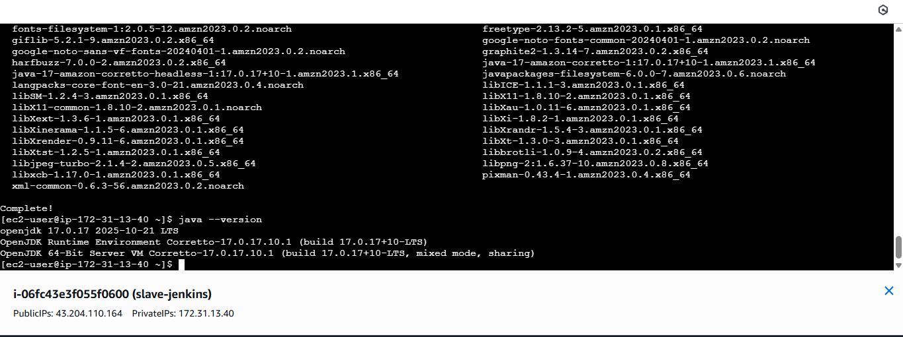
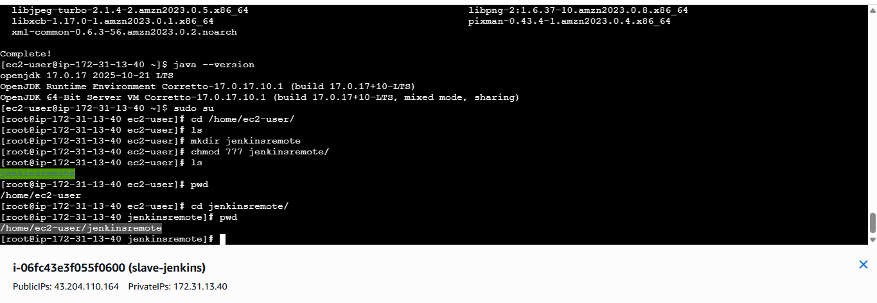
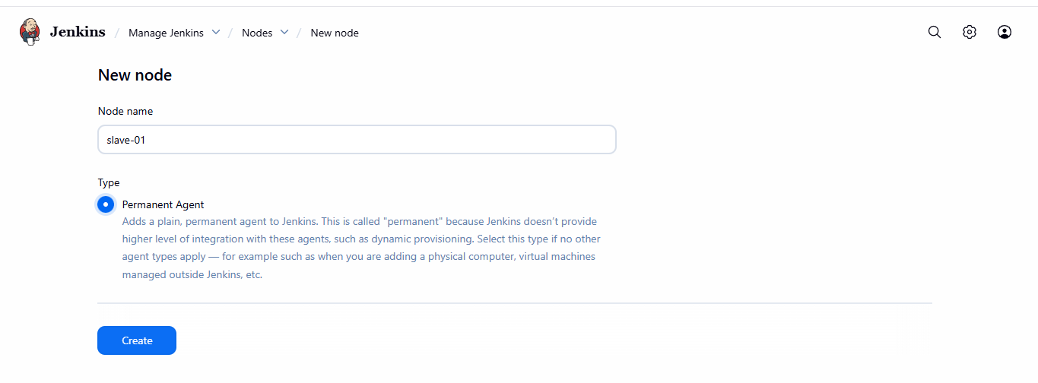
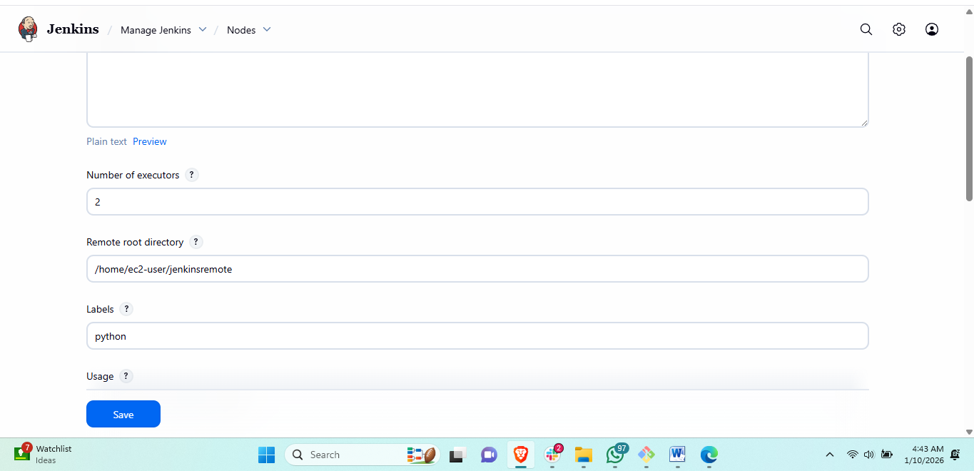
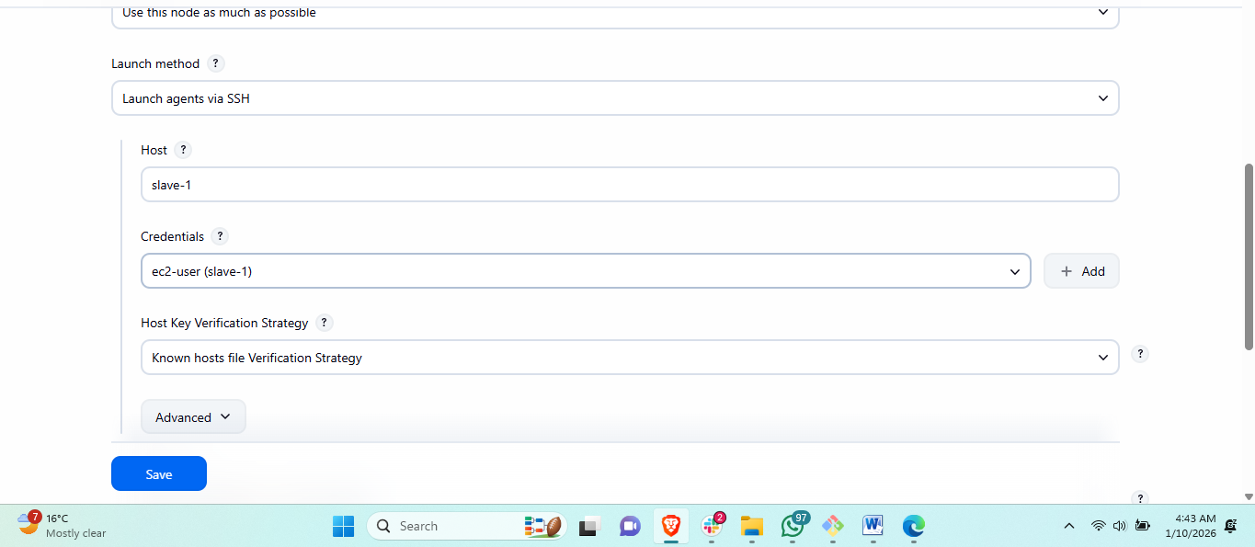
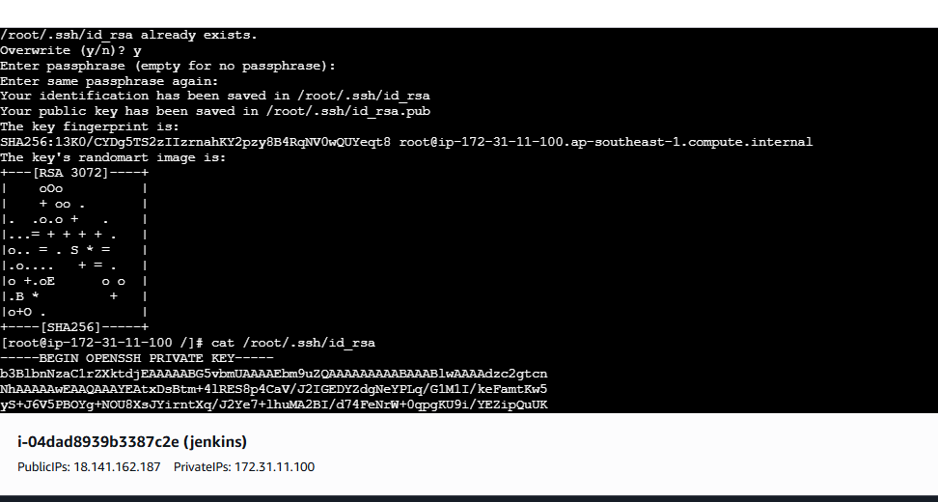
steps Jenkins Master–Slave (Agent) Configuration – Step by Step

🔹 Prerequisites (Before Starting)

Master (Jenkins Server)
- Jenkins installed & running
- Java installed
- SSH access
- Jenkins user exists (jenkins)

Slave (Agent Server)
- Linux server (EC2 / VM / On-prem)
- Java installed
- SSH running on port 22
- Network connectivity to Jenkins master

🔹 STEP 1: Install Java on SLAVE
Jenkins agent must have Java

Amazon Linux 2023
sudo dnf install java-17-amazon-corretto -y
Verify:
java --version

🔹 STEP 2: Verify Jenkins User on MASTER
On Jenkins master:
cat /etc/passwd | grep jenkins
You will see:
jenkins:x:992:992:Jenkins Automation Server:/var/lib/jenkins:/bin/false
👉 Jenkins runs as a non-login service user (this is correct).

🔹 STEP 3: Switch to Jenkins User (Correct Way)
On Jenkins master:
sudo su -s /bin/bash jenkins
Verify:
whoami
✅ Output must be:
jenkins

🔹 STEP 4: Generate SSH Key on MASTER (as Jenkins user)
Still as jenkins:
ssh-keygen -t rsa -b 4096
- Press ENTER for all prompts
- Keys created in:
- /var/lib/jenkins/.ssh/

🔹 STEP 5: Copy Jenkins Public Key to SLAVE

Method 1 (If password login allowed)
ssh-copy-id ec2-user@<SLAVE_PUBLIC_IP>

Method 2 (Manual – Recommended & Reliable)

On MASTER (jenkins user):
cat ~/.ssh/id_rsa.pub
Copy the output.

On SLAVE:
mkdir -p ~/.ssh
vi ~/.ssh/authorized_keys
Paste key → save.
Set permissions:
chmod 700 ~/.ssh
chmod 600 ~/.ssh/authorized_keys

🔹 STEP 6: Test SSH Connectivity (MANDATORY)
From Jenkins master (as jenkins):
ssh ec2-user@<SLAVE_PUBLIC_IP>
✅ Should connect without password
❌ If password asked → SSH is NOT ready

🔹 STEP 7: Configure Agent in Jenkins GUI

Jenkins UI Path:
Manage Jenkins → Nodes → New Node

Node Configuration:
Field | Value
Node name | slave-1
Type | Permanent Agent
Remote root directory | /home/ec2-user/jenkins
Labels | slave
Usage | Use this node as much as possible
Launch method | Launch agent via SSH

SSH Configuration:
Field | Value
Host | SLAVE_PUBLIC_IP
Credentials | SSH Username with private key
Username | ec2-user
Private key | Paste jenkins private key
Host Key Verification | Non-verifying (for lab)
👉 Save

🔹 STEP 8: Verify Agent Status
After saving:
- Node should show 🟢 Connected
- Log should show:
- Agent successfully connected

